# MINI PROJECT (2019-20)

**Alumni Connect**

**MINI PROJECT REPORT**

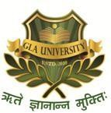

**Institute of Engineering & Technology**

**Submitted by**

**Ashita Vijay Seth**

**(181500145)**

**Prakhar Singh**

**(181500470)**

***Supervised by:***

**Mr. Neeraj Khanna**

# Department of Computer Engineering & Applications

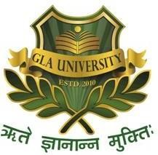**Department of computer Engineering and Applications**

**GLA University, Mathura**

**17 km. Stone NH#2, Mathura-Delhi Road, P.O. –Chaumuha,**

**Mathura – 281406**

# Declaration

We hereby declare that the work which is being presented in the B.Tech Project “Alumni Connect” is partial fulfillment of the requirement for the award of the Bachelor of Technology in Computer Science and Engineering at GLA University, Mathura is the authentic record of our team work carried under the supervision of **Mr. Neeraj Khanna Sir.**

## Signature :

## Name of Candidate: Ashita Vijay Seth University Roll No. : 181500145

## Name of Candidate: Prakhar Singh University Roll No. : 181500470

**ACKNOWLEDGEMENT**

It is our pleasure to acknowledge the assistance of a number of people without whose help this project would not have been possible.

First and foremost, we would like to express our gratitude to **Mr. Neeraj Khanna ,**  our project guide, for providing invaluable encouragement, guidance and assistance. After doing this project we can confidently say that this experience has not only enriched us with technical knowledge but also has unparsed the maturity of thought and vision. The attributes required being a successful professional.

We also do not like to miss the opportunity to acknowledge the contribution of all faculty members of the department for their kind guidance and co-operation during the development of our project.

Last but not least, we acknowledge our friends for their contribution in the completion of this project.

**ABSTRACT**

Usually, whenever we are stuck with any problem, we tend to seek advice from an experienced person in that field so that they can guide us to the right path. We are students and the person who is experienced in this field are our alumni.

Alumni is a term used for former person specifically a student, of a particular school, college or University. Alumni serve many valuable roles, such as helping to build and grow an institution’s brand through word-of-mouth marketing. For instance, positive posts on social media can create buzz and increase application rates. Colleges also rely on alumni to provide mentoring, internships, and career opportunities to students.

Among all the above mentioned roles, we are focusing on the job/internship or in simple words any career related opportunities and guidance that benefits the students. Alumni are resources that can provide meaningful and mutually beneficial relationships over time.

**Certificates**

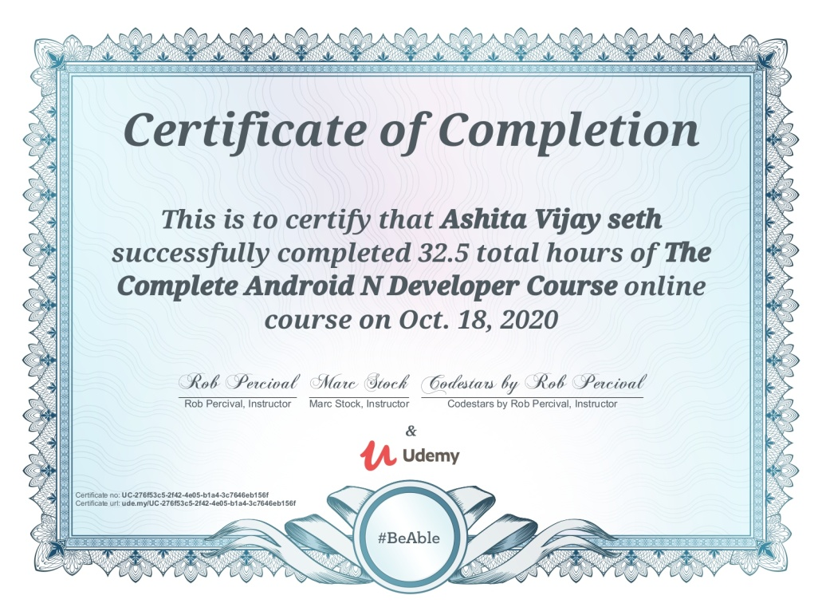

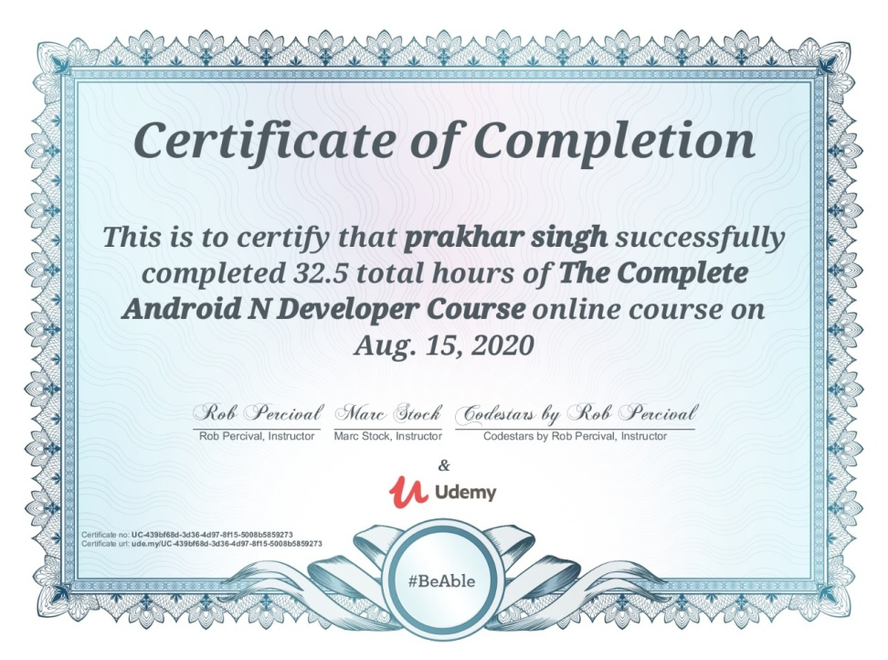

**Table of Content**

Declaration i

Acknowledgement ii

Abstract iii

Certificates.……………………………………………………………iv

1. Introduction 7

## 1.1 Problem Statement

1.2 Motivation

1.3 Objective

1.4 Feasibility Study

1.5 Scope

|  |  |  |  |  |
| --- | --- | --- | --- | --- |
| 1. **Software Requirement Specification**   2.1 Hardware and Software Requirements  2.2 Specific Requirements  2.2.1 Java  2.2.2 Firebase  2.2.3 Android Studio | | | **10** |  |
|  |  |
|  |
|  |
|  | | |  |  |
| **3. Software Design** | | |  | **16** |
| 3.1 Area of Computer Science | | |  |  |
| 3.2 Workflow Diagram | | |  |  |
| 3.3 Use Case Diagram  3.4 Data Flow Diagram   * 1. Wireframes | | |  |  |
| **4. Testing**  4.1 Introduction  4.2 Design of Test Cases and Scenarios | | |  | **46** |
| **5. Implementation and Interface** | | |  | **48** |
| **6. Conclusion** | | |  | **75** |
| **7. Bibliography** | | |  | **76** |
| **CHAPTER 1**  **Introduction** | | |  |  |

**1.1 The Problem Statement**

An alumnus is a term used for former person specifically a student, of a particular school, college or University.

During one of a Meet-up with our Alumni, we started talking about the life in corporate. He told us about the how he started off as a beginner and is now doing great in his field. He told us the things that he wished he could knew earlier. We realized that there are a lot of myths going around about the corporate life. Myths like – “We don’t have to work hard after securing a good job” or “Everything is taught to us during the 4 years of college”. Corporate Life is not about studies, it is so much more.

Apart from this, we ended up discussing about how IIT-ians (Students of IIT) do great in every sector and secure a very good job. He told us that in IIT’s students keep in touch with the alumni, which not only help them to learn about corporate sector but also helps them to score a good internship or training program in a valuable organization.

Alumni serve many valuable roles, such as:

1. Helping to build and grow an institution’s brand through word-of-mouth marketing. For instance, positive posts on social media can create buzz and increase application rates.
2. Can provide mentoring, internships, and career opportunities to students.
3. Any career related opportunities that benefit the students. Alumni are resources that can provide meaningful and mutually beneficial relationships over time

Through this meet-up we realized the importance of Alumni, so we decided to develop an app where the students can connect with their alumni.

**1.2 Motivation**

During one of a Meet-up with our Alumni, we started talking about the life incorporate. He told us about the how he started off as a beginner and is now doing great in his field. He told us the things that he wished he could knew earlier. We realized that there are a lot of myths going around about the corporate life. Myths like – “We don’t have to work hard after securing a good job” or “Everything is taught to us during the 4 years of college”. Corporate Life is not about studies, it is so much more.

Apart from this, we ended up discussing about how IIT-ians (Students of IIT) do great in every sector and secure a very good job. He told us that in IIT’s students keep in touch with the alumni, which not only help them to learn about corporate sector but also helps them to score a good internship or training program in a valuable organization.

Through this meet-up we realized the importance of Alumni, so we decided to develop an app where the students can connect with thir alumni.

**1.3 Objective**

The main objective of this project is to improve communication between Alumni and Students. With this project, we aim to create a meaningful relationship with our alumni.

As told earlier, alumni are resources that can provide meaningful and mutually beneficial relationships over time. We aim to provide students with opportunities through our alumni in every sector. A valuable guidance, a mirror to the corporate world, we want the students to know it all before they enter the corporate world. We want the students to know, what our alumni would have wanted to know when they were that young.

## During the last Semester, we have worked on the project “E-bridge GLAU”, that acted as a bridge between students and the faculty. We aim to continue out project and turn it to a bridge between Alumni and Students.

**1.4 Feasibility Study**

## Considering the current situation, this application will welcome many opportunities which will be beneficial for the students and their career. It can be used in the long run. It will act as a bridge between Alumni and Students. Not only it will help the students by providing them with valuable guidance and opportunities but also, it will help them prepare for the corporate world. It will help them to understand the work ethics that need to be followed in an organization. The University will have a personal application for communication. Our main focus is to connect the students to their Alumni.

## 

The application will be extremely user-friendly with well-designed screens and limited inputs.

**1.5 Scope**

**This app can be the official Alumni Connect application for our own University as we will constantly update it with new features in the future which will make the application more user friendly. This can be used as the main University Alumni Connect app. We are proposing a new form of technology to get communication between Alumni and Student.**

**Also, through this application, the students will benefit in so many different ways, like-** facing interviews, Internship opportunities, training opportunities, myths about corporate life, and many more.

**CHAPTER 2**

**Software Requirement Specifications**

**2.1 Hardware and Software Requirements**

# Hardware Requirements

* + - * System: Intel i3 3rd generation or above
      * Hard Disk: 40GB
      * An Android Phone
      * 2 GB RAM Required(Min.)

**Limitations and Constraints**:

* The Phone must be connected with Internet
* This app can only be installed on android devices

# Software Requirements

* + - * Any OS
      * Coding Language: Java
      * Tool Kit: Android SDK
      * Firebase
      * IDE: Android Studio
      * Adobe Illustrator

# 2.2 Specific Requirements

**2.2.1 Java**

Java is a cross-platform object-oriented programming language that was released by Sun Microsystems in the year 1995. Today, Java is needed to run various applications such as games, social media applications, audio and video applications, etc.

**2.2.1.1 History**

Java is a programming language developed by **James** **Gosling** with other team members named **Mike Sheridan** and **Patrick Naughton** also called as **Green Team** in **1995** for **Sun Microsystems** for digital devices such as set-top boxes, televisions etc. Now, let us explore the language in detail.

**2.2.1.2 What is Java?**

It is an object-oriented language similar to C++, but with advanced and simplified features. This language is **free to access** and can **run** on **all platforms**.

Java is: –

* **Concurrent** where you can execute many statements instead of sequentially executing it.
* **Class-based** and an **object-oriented** programming language.
* **Independent** programming language that follows the logic of “**Write once, Run anywhere**” i.e. the compiled code can run on all platforms which supports java.

**2.2.1.3 Features**

* Java has made life easier by removing all the complexities such as pointers, operator overloading as you see in C++ or any other programming language.
* This is platform independent which means that any application written on one platform can be easily ported to another platform.
* Everything is considered to be an “**object**” which possess some state, behavior and all the operations are performed using these objects.
* All the code is converted in **byte code** after compilation, which is not readable by a human. and java does not use an explicit pointer and run the programs inside the sandbox to prevent any activities from un-trusted sources. It enables to develop virus-free, tamper-free systems/applications.
* Java supports multiple threads of execution (a.k.a., lightweight processes), including a set of synchronization primitives. This makes programming with threads much easier.

**2.2.1.4 Components**

* **JVM (Java Virtual Machine)**

It is the tool necessary to:-

* Compile
* Document
* Package Java programs.

The JDK completely includes JRE which contains tools for programmers. The Development Kit is provided free of charge. Along with JRE, it includes an interpreter/loader, a compiler (javac), an archiver (jar), a documentation generator and other tools needed in Java development. In short, it contains JRE + development tools.

* **JVM (Java Virtual Machine)**

JRE refers to a runtime environment in which bytecode can be executed. It implements the JVM and provides all the class libraries and other support files that JVM uses at runtime. So JRE is a software package that contains what is required to run a program. Basically, it’s an implementation of the JVM which physically exists.

* **JVM (Java Virtual Machine)**

It is an abstract machine. It is a specification that provides a run-time environment in which the bytecode can be executed. It follows three notations

* **Specification**: It is a document that describes the implementation of the JVM. It is provided by Sun and other companies.
* **Implementation**: It is a program that meets the requirements of JVM specification.
* **Runtime Instance**: An instance of JVM is created whenever you write a command on the command prompt and run the class.

**2.2.2 Firebase**

Firebase is a mobile- and web application development platform, backed by Google, to help developers deliver richer app experiences.

The platform consists of a great set of development tools. The **Realtime Database** and **Cloud Firestore** can stock document-structured data and synchronize the corresponding apps in milliseconds whenever a data transformation occurs. This means that both the app and its database listen to each other, providing the user with reactive app experiences. And Firebase **Cloud Functions**can even extend this functionality. These functions allow the developer to write backend code to respond to events happening in the Firebase platform without having to deal with any servers.  With Firebase **Authentication** you can verify users through both social and e-mail logins and manage them securely. Firebase **Hosting** can deploy both static and dynamic content to web apps and **Cloud Storage** can accumulate and serve a huge amount of files. Last but not least, there's **ML Kit**. This module brings machine learning to your app with ready-to-use APIs and custom models using TensorFlow Lite, an open source machine learning platform by Google.

**2.2.3 Android Studio**

Android Studio is the official Integrated Development Environment (IDE) for Android app development, based on [IntelliJ IDEA](https://www.jetbrains.com/idea/). On top of IntelliJ's powerful code editor and developer tools, Android Studio offers even more features that enhance your productivity when building Android apps, such as:

* A flexible Gradle-based build system
* A fast and feature-rich emulator
* A unified environment where you can develop for all Android devices
* Apply Changes to push code and resource changes to your running app without restarting your app
* Code templates and GitHub integration to help you build common app features and import sample code
* Extensive testing tools and frameworks
* Lint tools to catch performance, usability, version compatibility, and other problems
* C++ and NDK support
* Built-in support for [Google Cloud Platform](https://cloud.google.com/tools/android-studio/docs/), making it easy to integrate Google Cloud Messaging and App Engine

**CHAPTER 3**

**Software Design**

This is the designing portion of the project which defines software solutions to one or more sets of problem. One of the main component of software design is the software requirement analysis.

**3.1 Area of Computer Science**

he Alumni Connect application is an android application which mainly aims to improve communication between Alumni and students. This application actually consists of two modules, those are the Admin module and Student module, where they can access and operate the application from their respective ends. We focused on both sides which will help both the Alumni and the students.

In general, the Admin will maintain the entire administration like Authorization, Authentication, permissions, History tracking, and troubleshooting, etc. The Admin(Alumni) can share the job opportunities or any important notices which they would want to share with the students. Also, the Admin can share e-books, Question-Answer PDF, Interview Questions, etc. to the students through our Admin panel. Admin Panel also include basic activities like adding new Alumni, updating an existing Alumni and deleting an existing Alumni. Alumni can also share their experience, be it interview experience, work experience or any other real life experience which may benefit the students in one way or the other.

The application is made extremely user friendly.

The Student will access all information like notices, PDFs, e-books, etc. and maintain a good relationship with the alumni. They can send or receive any kind of information like Clarification, Queries and guidance by connecting with the alumni. The student can ask for Doubts in Alumni section. Students can get the latest information regarding career opportunities and career guidance. Whenever in doubt, they can consult to their alumni regarding that issue. Also, they get to know their Experience and avoid doing the mistakes their alumni did. They can get a closer look at the corporate world. The Alumni would act as a Mirror to the corporate world.

In this Alumni Connect Android project, we are proposing a new form of technology to get communication between Alumni and Students.

**3.2 Workflow Diagram**

Given below is the knowledge diagram of the project

Admin Application

(Alumni App)

View

Notice/Article

View Alumni

Upload Study Material

Upload Notice/Article

Upload Images

Add Alumni

Update Info

Delete Alumni

**Dig 3.2.1 Work flow diagram of Admin Application**

User Application

(Student application)

About College Life

Study Material

Website

Notices/

Articles

Alumni Details

Gallery

Home

Download Study material

Connect to Alumni

# Dig 3.2.2 Work flow Diagram of User Application

**3.3 Use-Case Diagram**

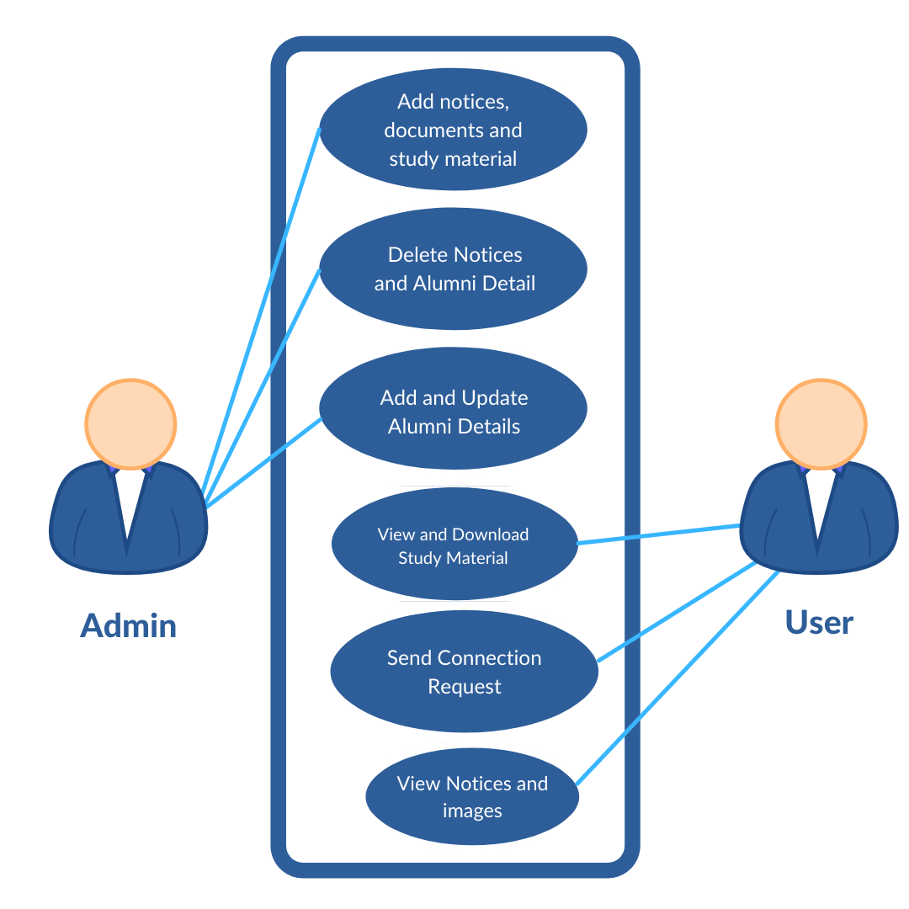

# Dig 3.3.1 Work flow Diagram of User Application

**3.4 DFD level 0**

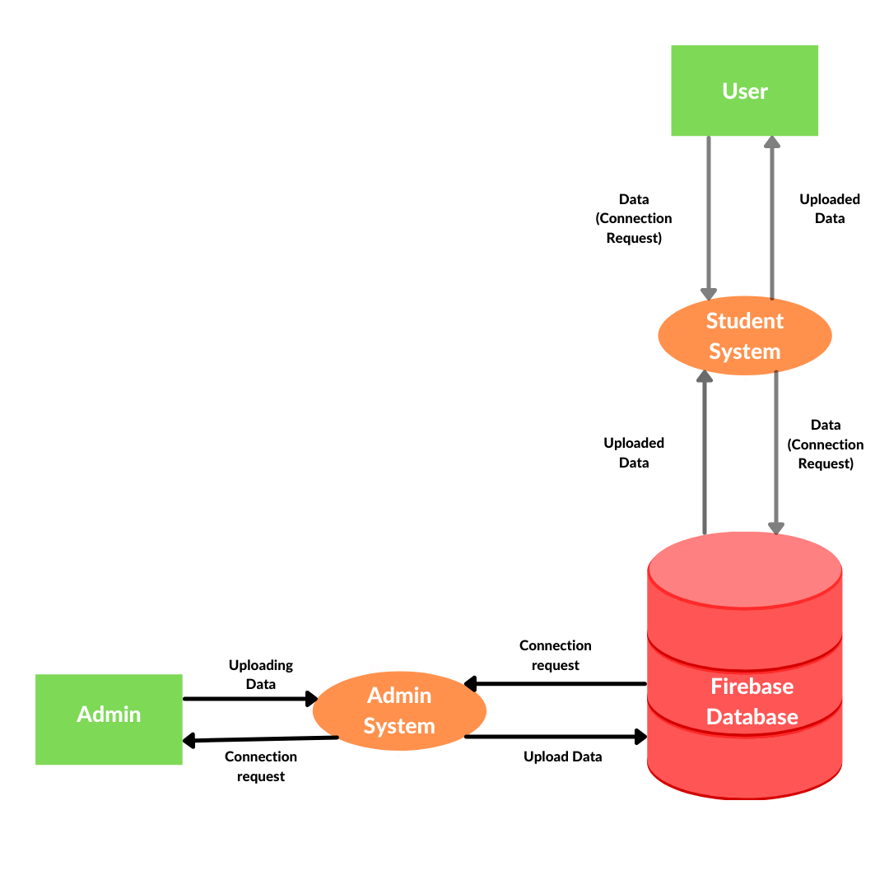

**Dig 3.4.1 Work flow Diagram of User Application**

**3.5 Wireframes**

**3.5.1 Admin Application**

**3.5.1.1 Admin Dashboard Activity**

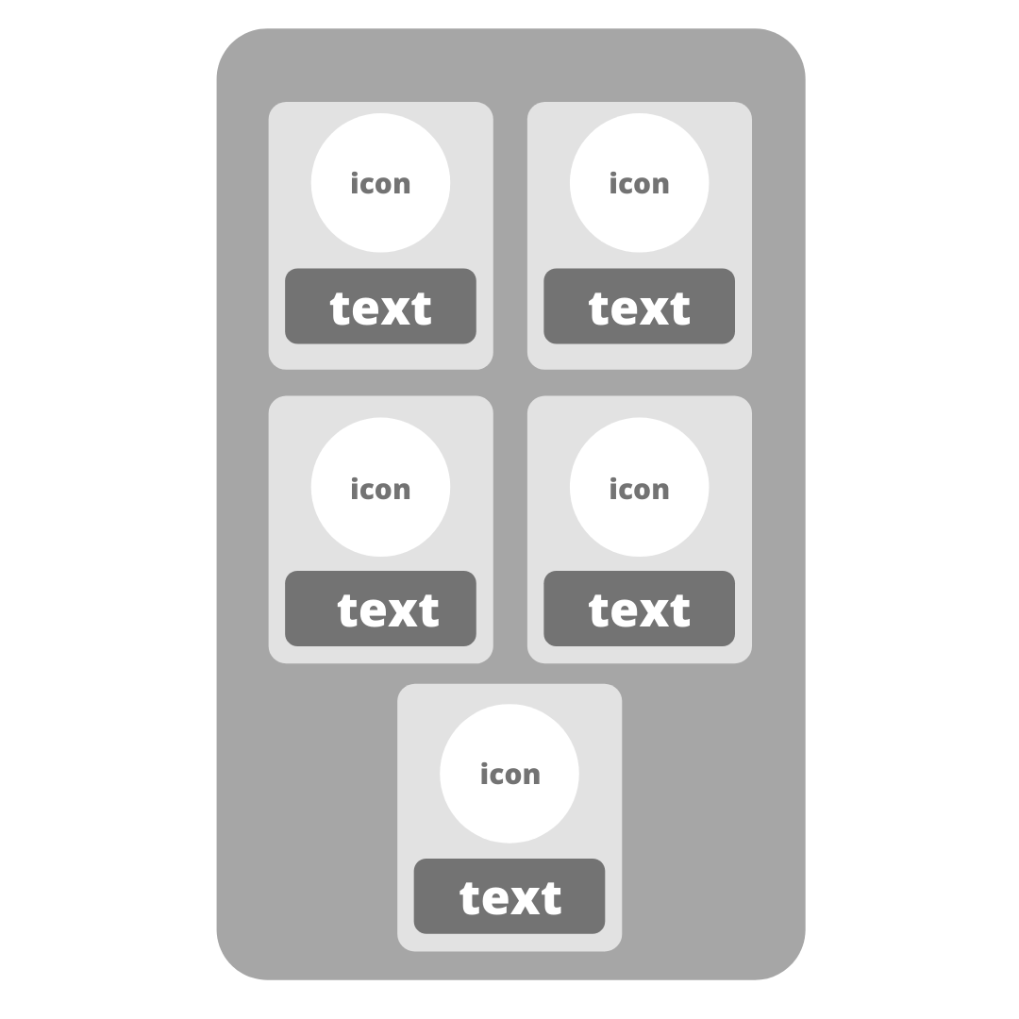

**3.5.1.2 Upload Notice Activity**

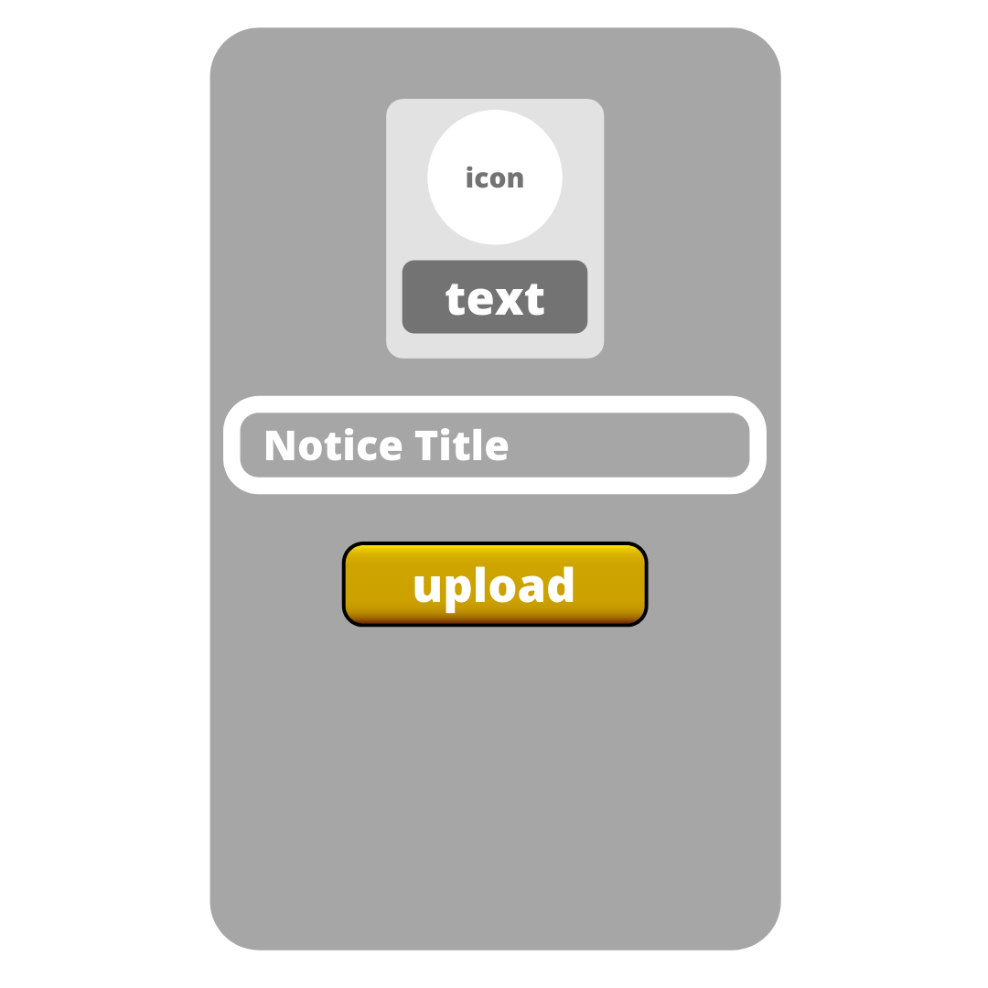

**3.5.1.3 Upload Image Activity**

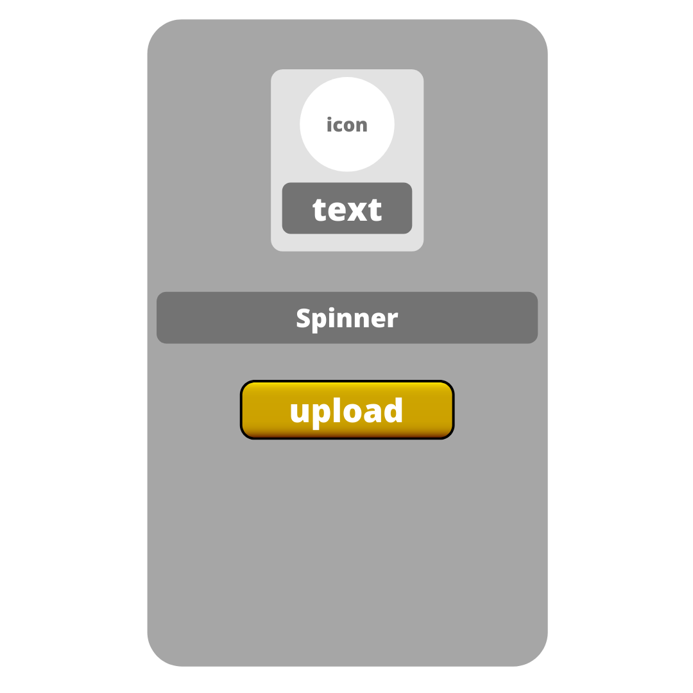

**3.5.1.4 Upload Study Material Activity**

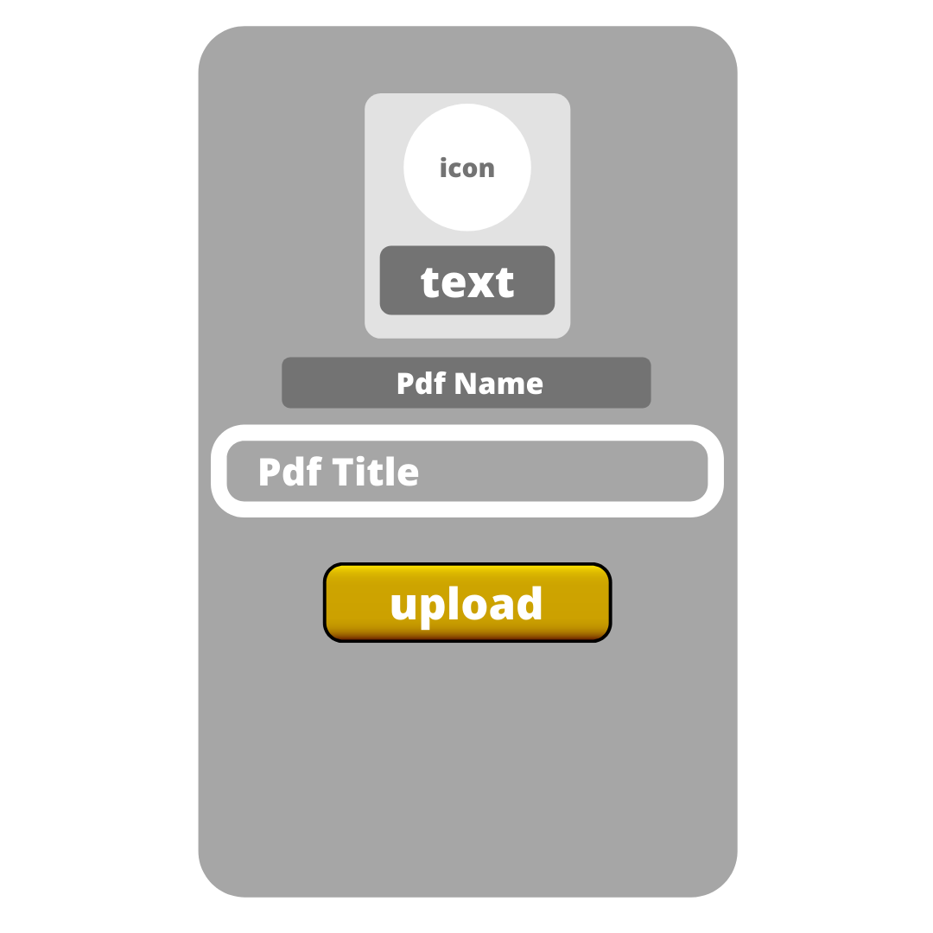

**3.5.1.5 Alumnus Activity**

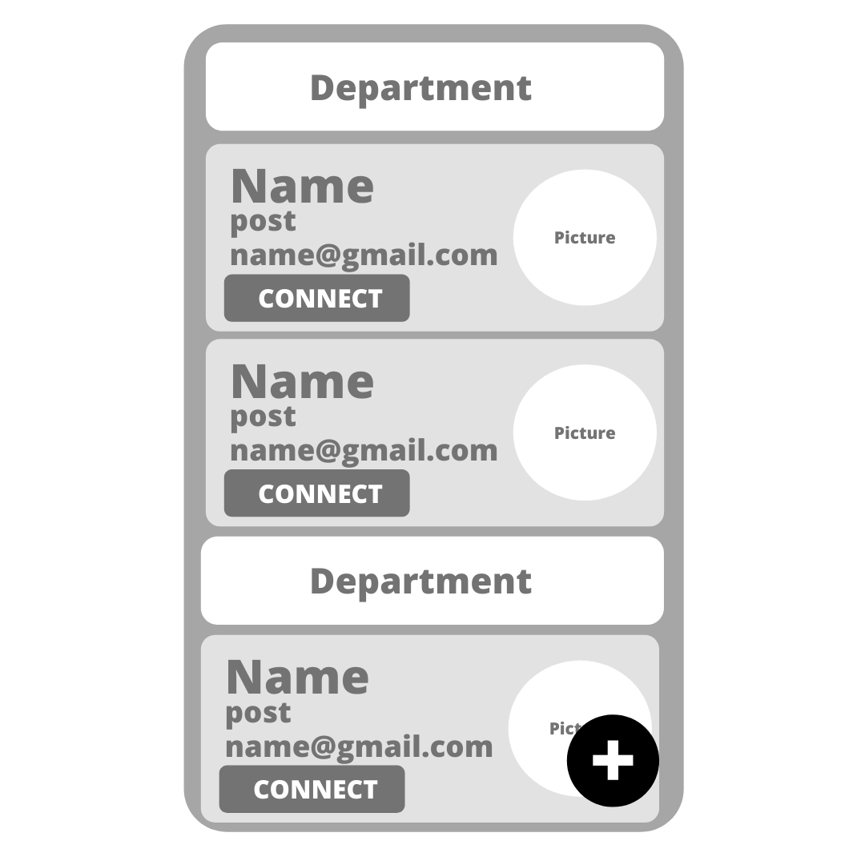

**3.5.1.6 Add Alumnus Activity**

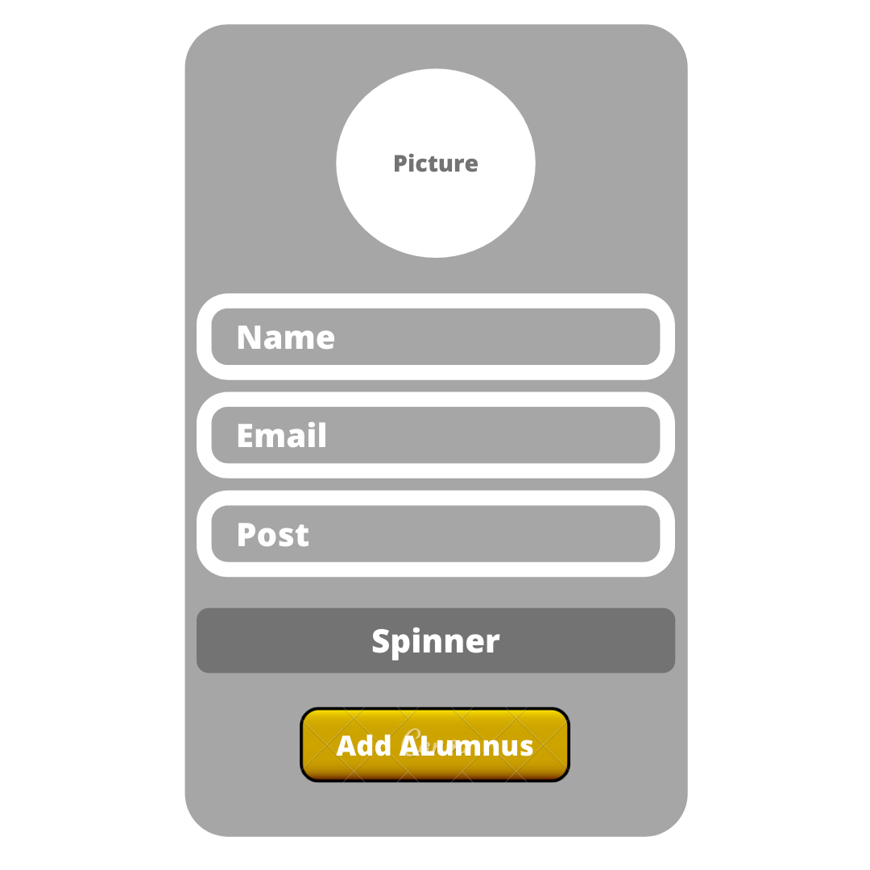

**3.5.1.7 Recycler View for Faculty**

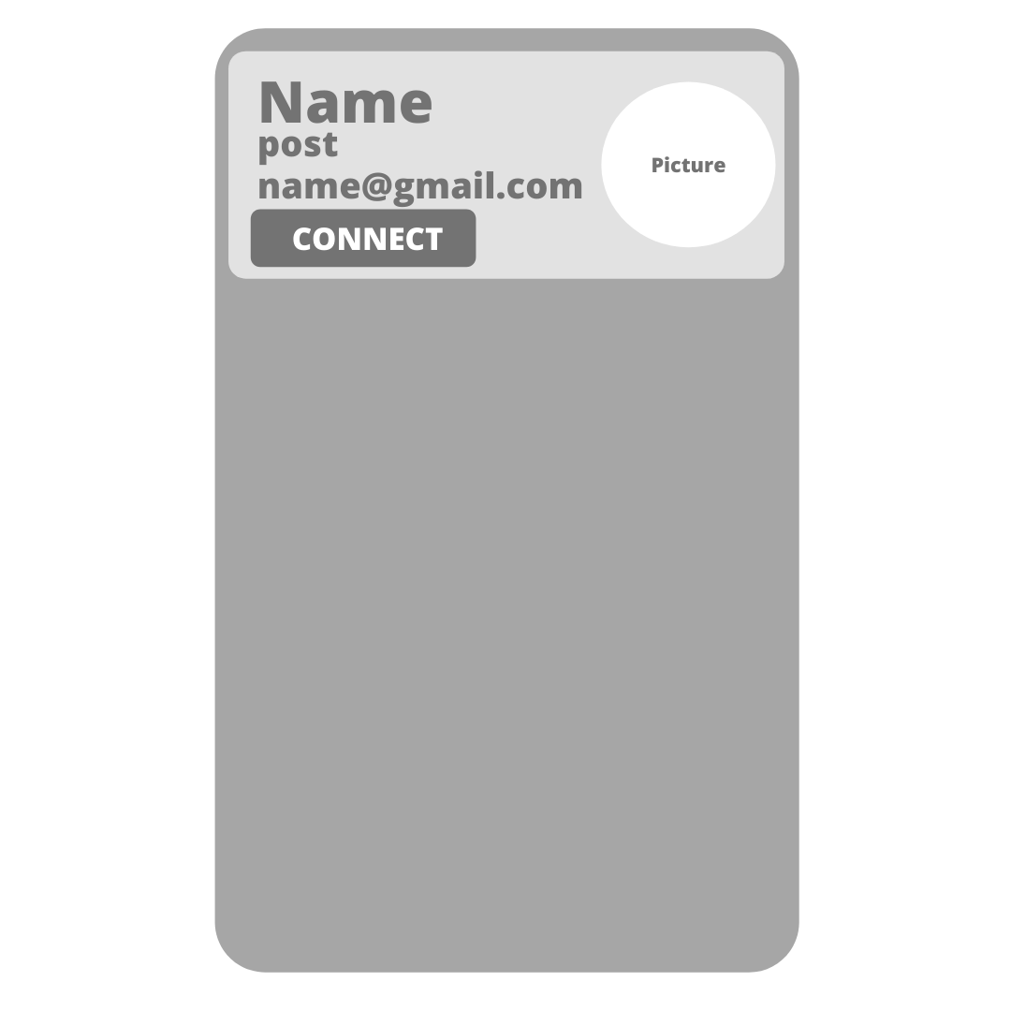

**3.5.1.8 Recycler View for Delete Notice Activity**



**3.5.1.9 Delete/Update Alumnus Activity**

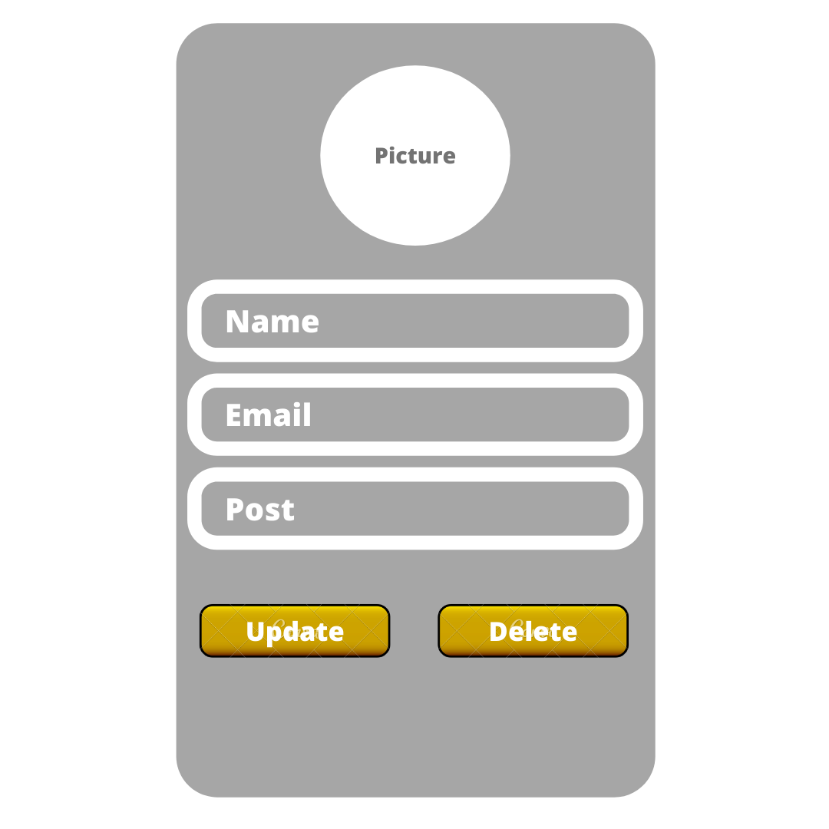

**3.5.1.10 Login Activity**

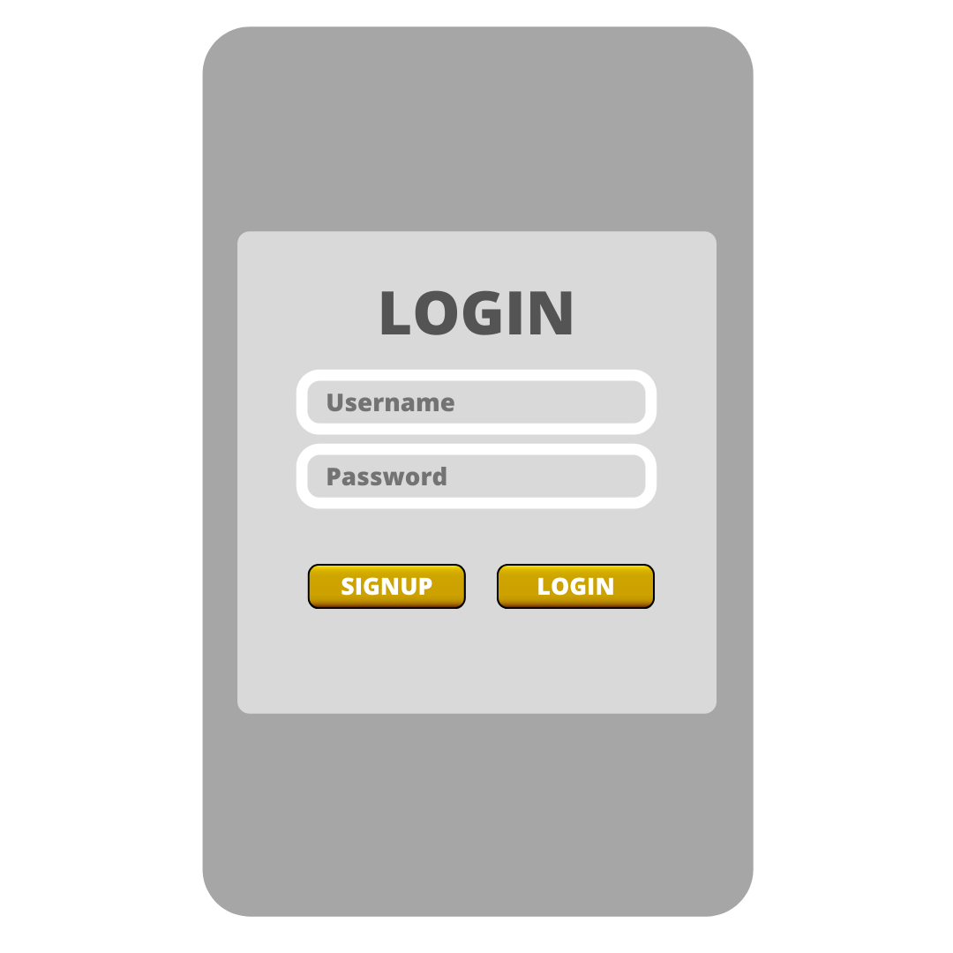

**3.5.1.11 Signup Activity**

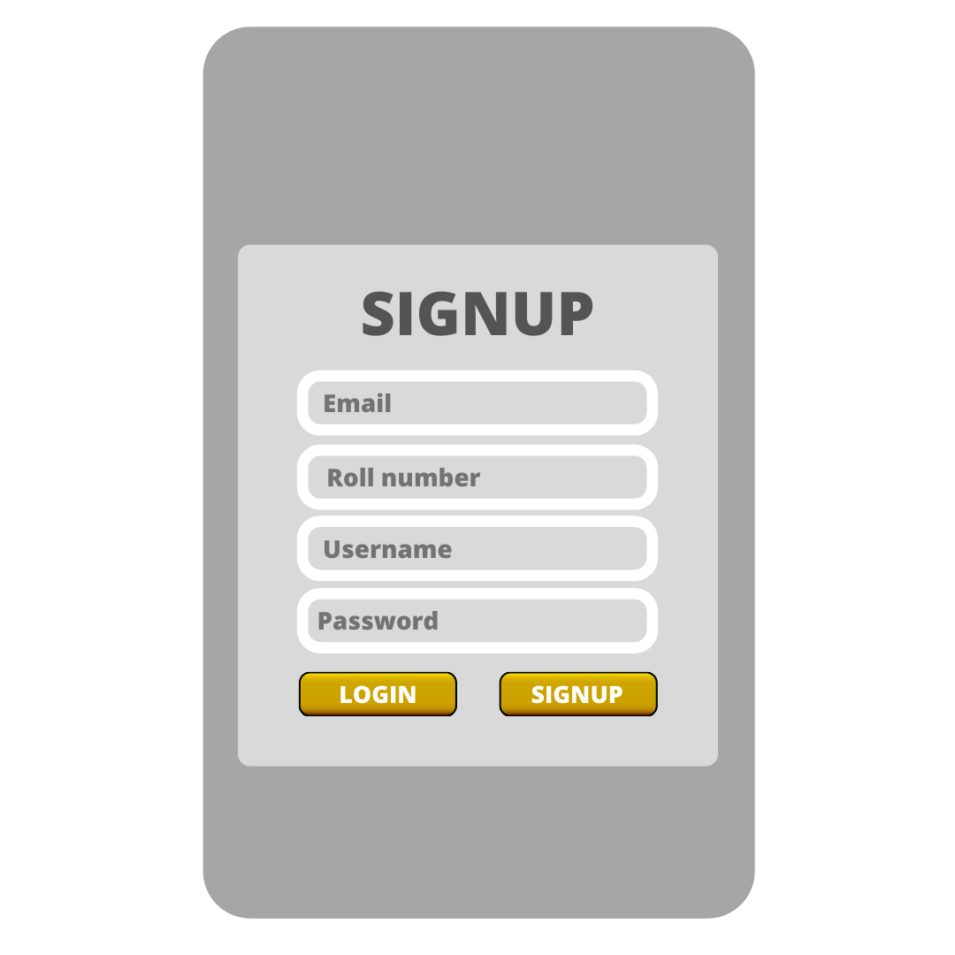

**3.5.2 User Application**

**3.5.2.1 User Dashboard**



**3.5.2.2 Bottom Navigation Bar**



**3.5.2.3 Drawer**

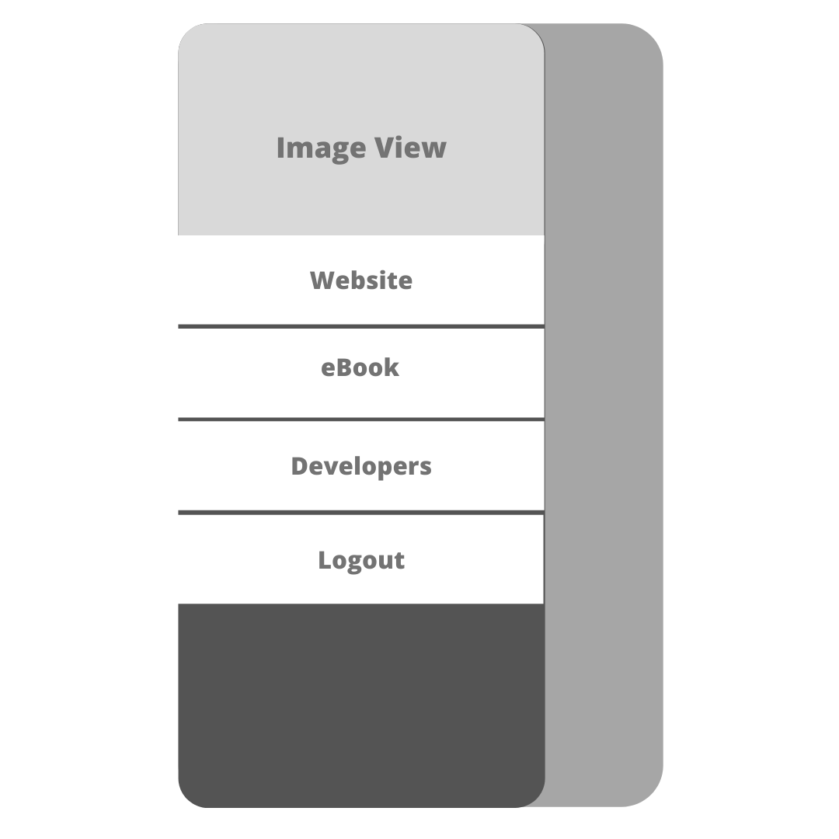

**3.5.2.4 Gallery Activity**

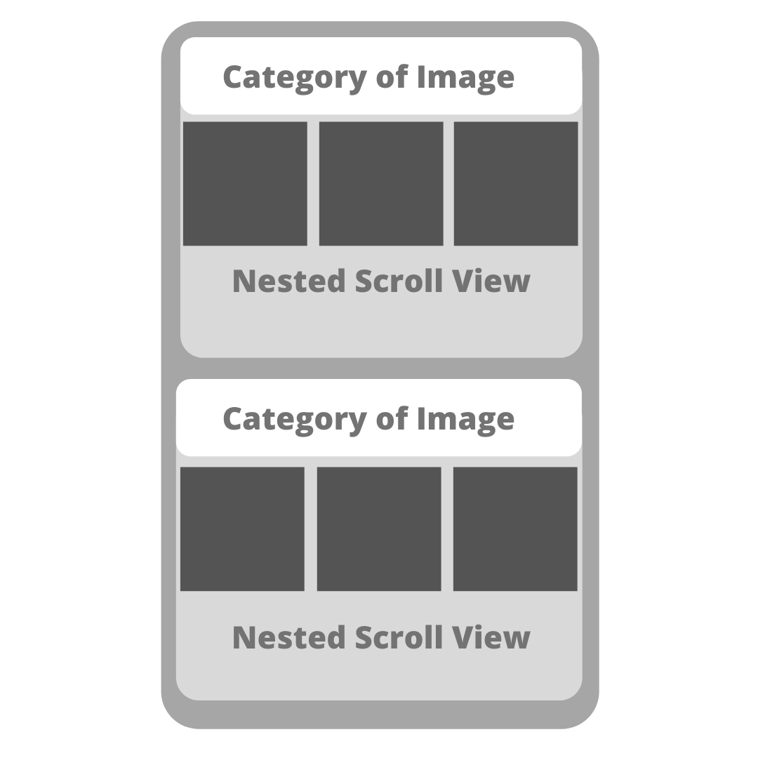

**3.5.2.5 Alumnus Activity**

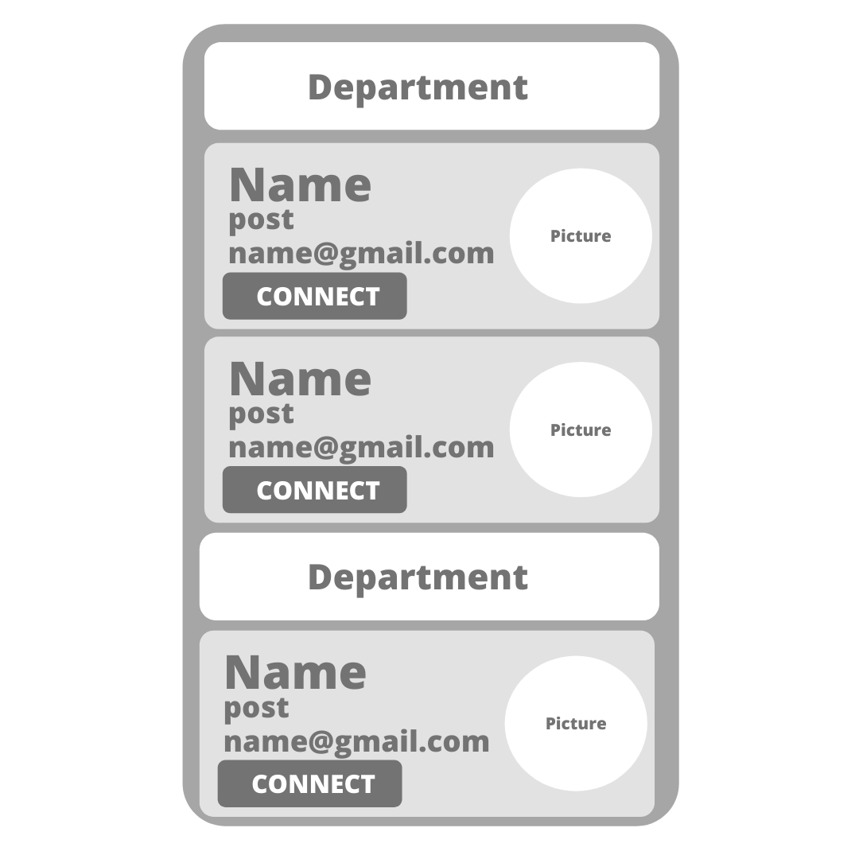

**3.5.2.6 Recycler View for Faculty Activity**



**3.5.2.7 Notice Activity**

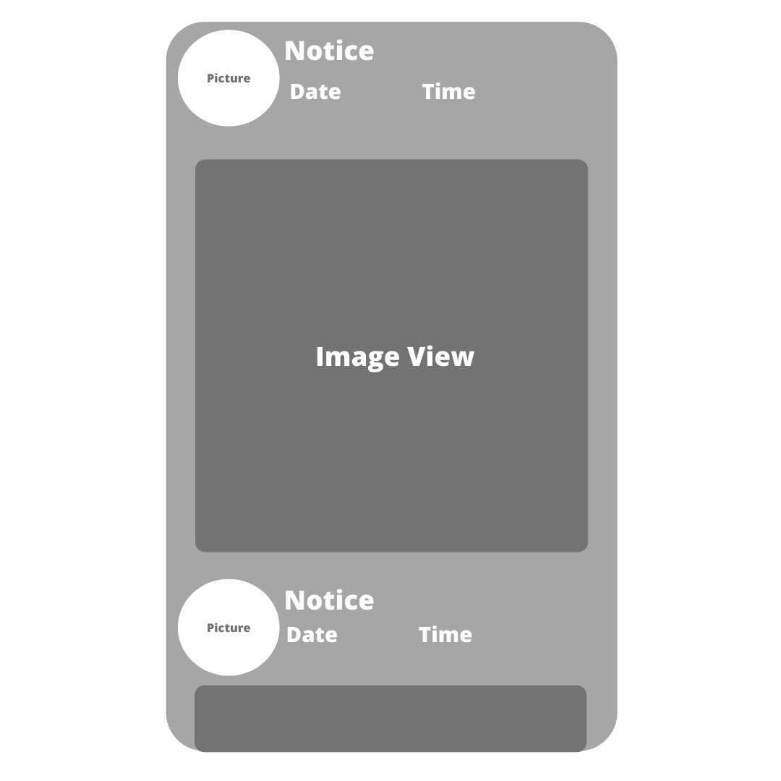

**3.5.2.8 Recycler View for Notice Activity**



**3.5.2.9 About Us Activity**

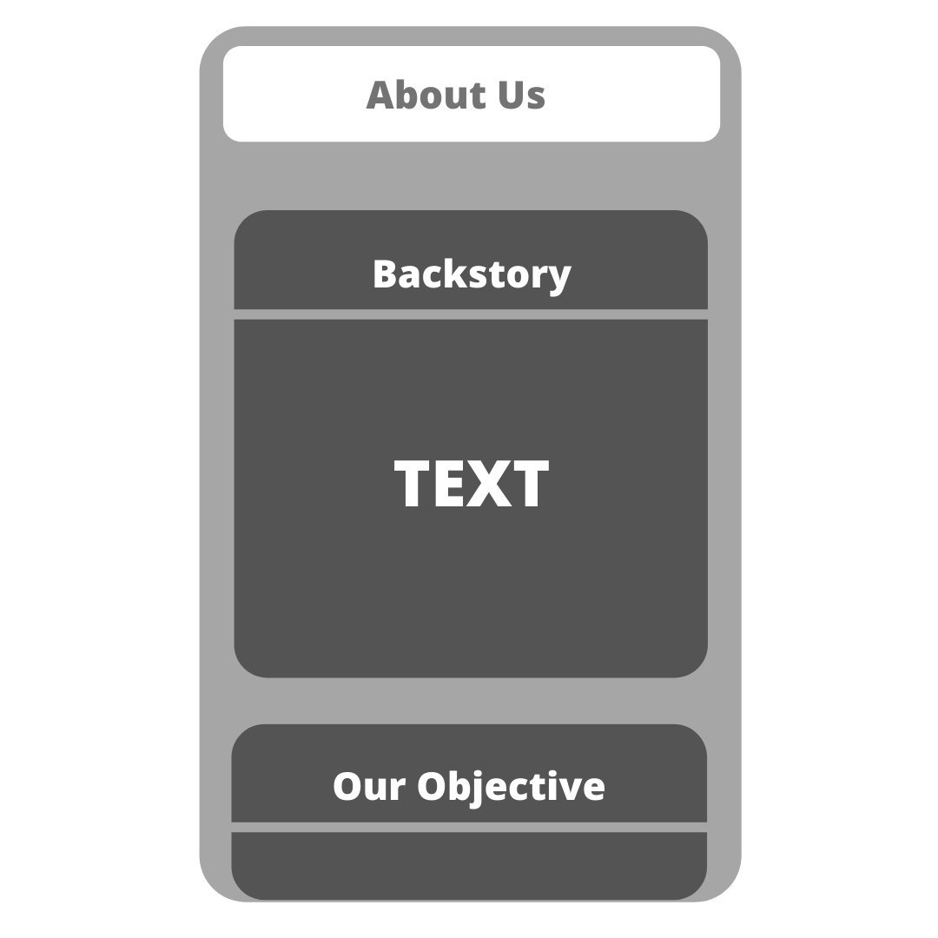

**3.5.2.10 Study Material Activity**

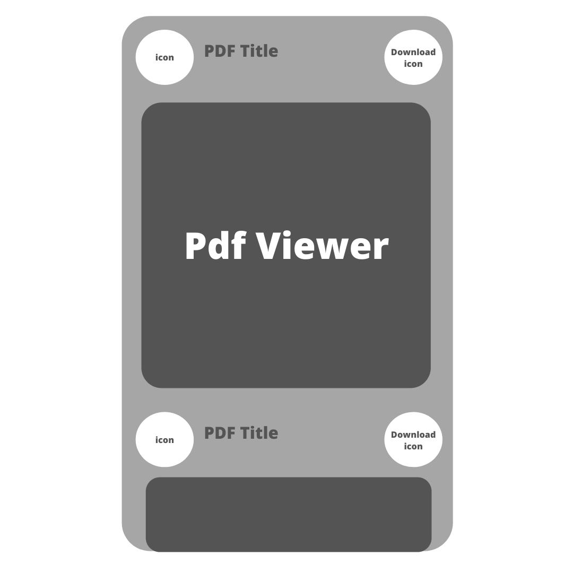

**3.5.2.11 Recycler View for Study material Activity**

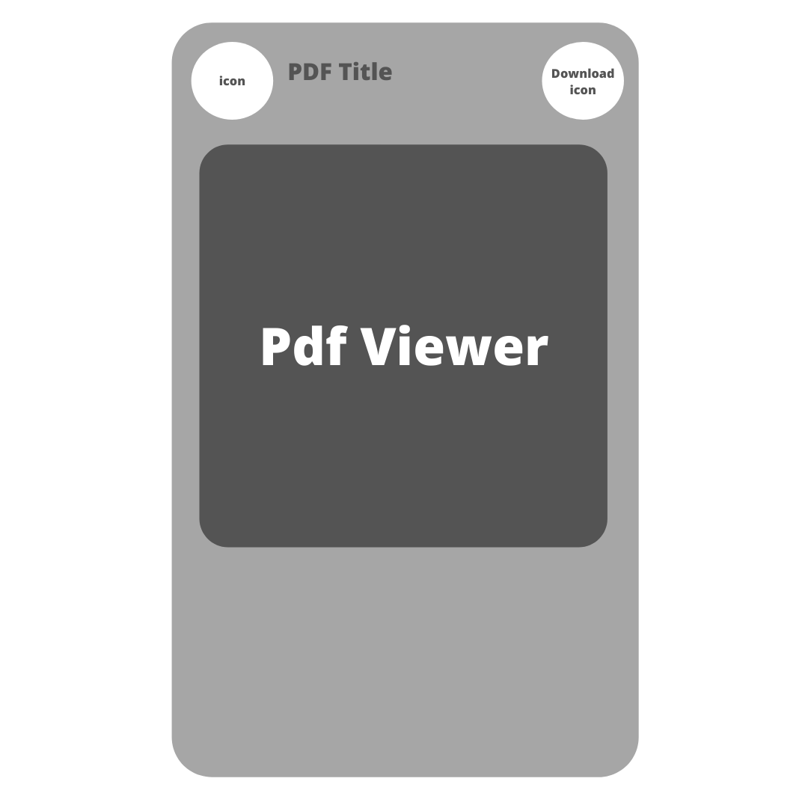

**3.5.2.12 Developers Activity**

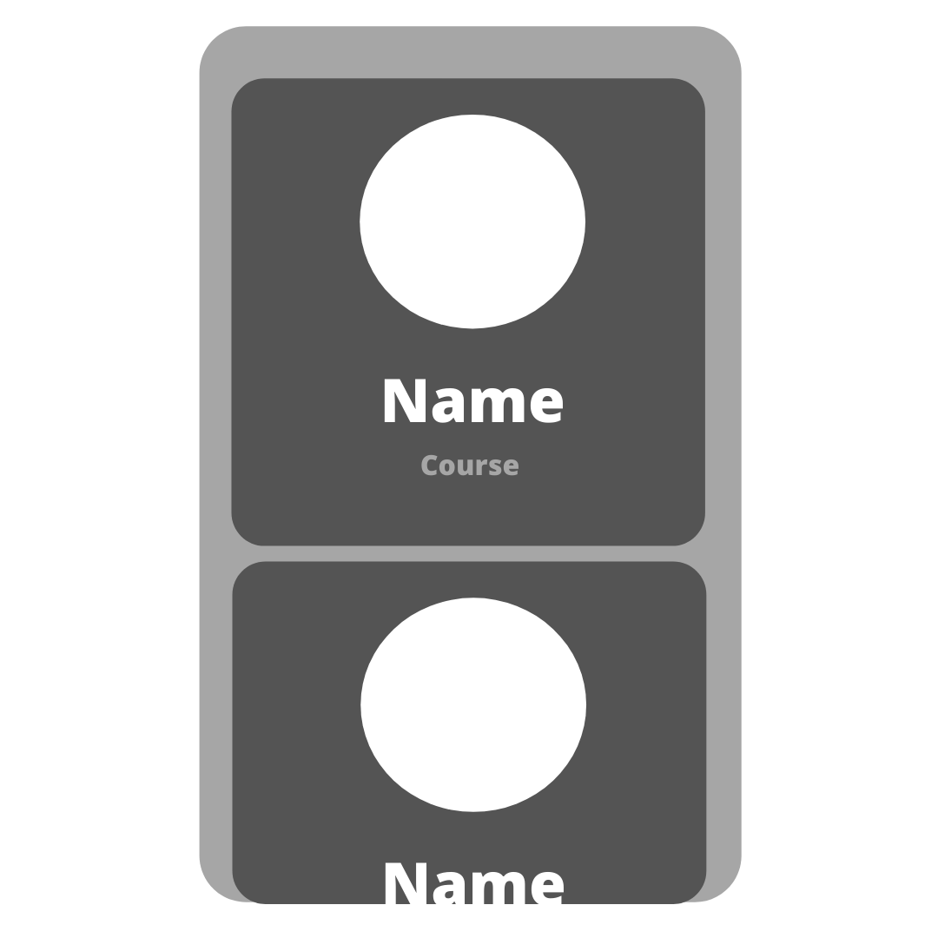

**3.5.2.12 Login Activity**



**3.5.2.13 Signup Activity**



**CHAPTER 4**

**Testing**

**5.1 Introduction**

Software testing is a critical element of software quality assurance and represents the ultimate review of specification, design and coding. In fact, testing is the one step in the software engineering process that could be viewed as destructive rather than constructive.

A strategy for software testing integrates software test case design methods into a well- planned series of steps that result in the successful construction of software. Testing is the set of activities that can be planned in advance and conducted systematically. The underlying motivation of program testing is to affirm software quality with methods that can be economically and effectively apply to both strategies to both large and small scale system.

The following are the Testing Objectives:

* + - Testing is a process of executing a program with the intent of finding an error.
    - A good test has a high probability of finding an as yet undiscovered error.
    - A successful test is one that uncovers an as yet undiscovered error.

### 5.2 Design of Test cases & scenarios

The objective is to design tests that systematically uncover different classes of errors and do so with a minimum amount of time and effort. Testing cannot show the absence of defects. It can only show that software defects are present.

**5.2.1 Functional Testing**

[Functional software testing](https://testlio.com/solutions/functional-testing-service-tools-company/) ensures that the application is, well, functioning, correctly. This type of testing focuses on the main purpose and flow of the app, ensuring that all its features are responsive and meet specifications.

* The application installs and launches correctly
* The users can sign-up and login
* Text boxes and buttons function properly
* Push notifications render correctly

**5.2.2 Usability Testing**

Known as user experience testing, [usability testing](https://testlio.com/solutions/usability-testing/) checks how user-friendly the app is in terms of ease of use and intuitiveness. Ideally, usability testing revolves around the entire app-driven customer experience with insights that include the identification of bugs and recommendations for ways to improve the user experience, both in and out of the app.

Keep in mind the following:

* Good layout and design
* Intuitive
* Response time

**CHAPTER 5**

**User Implementations and Interface**

**5.1 Admin Application**

**5.1.1 Dashboard**

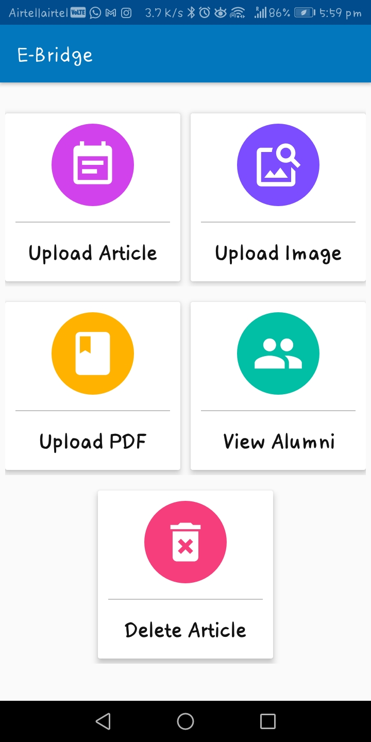

**5.1.2 Upload Notice**

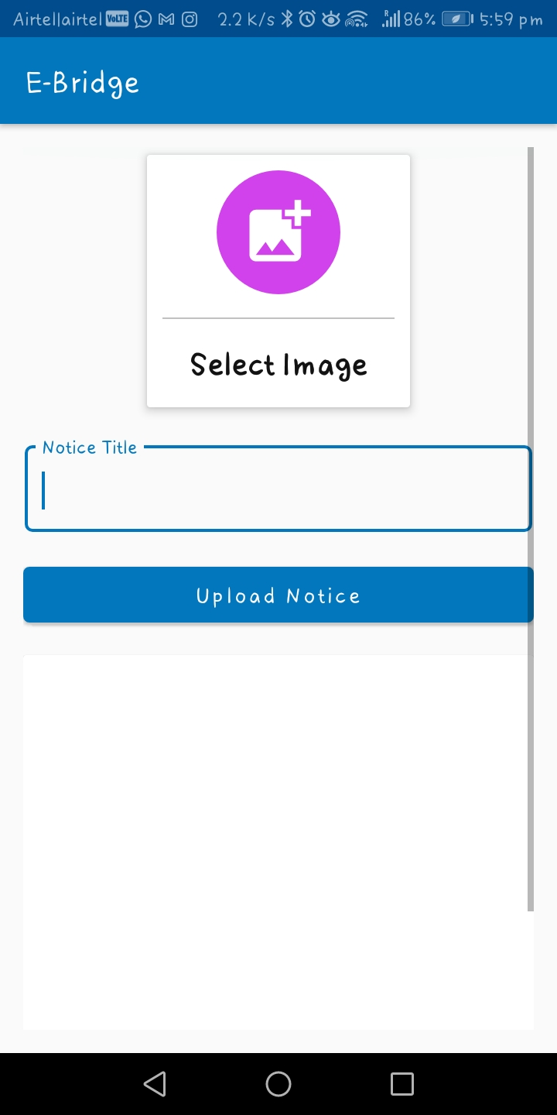

**5.1.3 Upload Image**

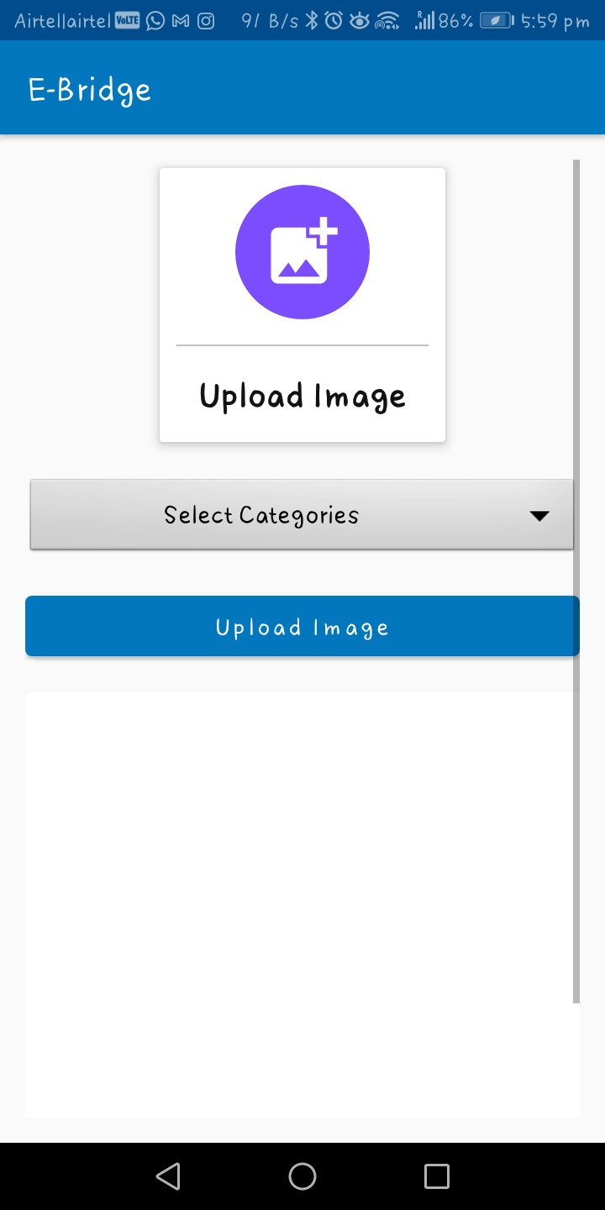

**5.1.4 Upload Study Material**

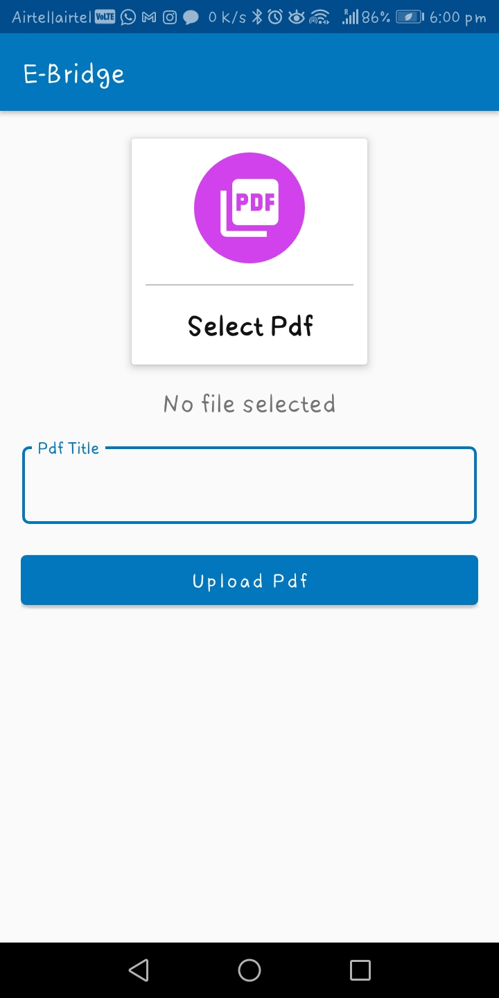

**5.1.5 View Alumni**

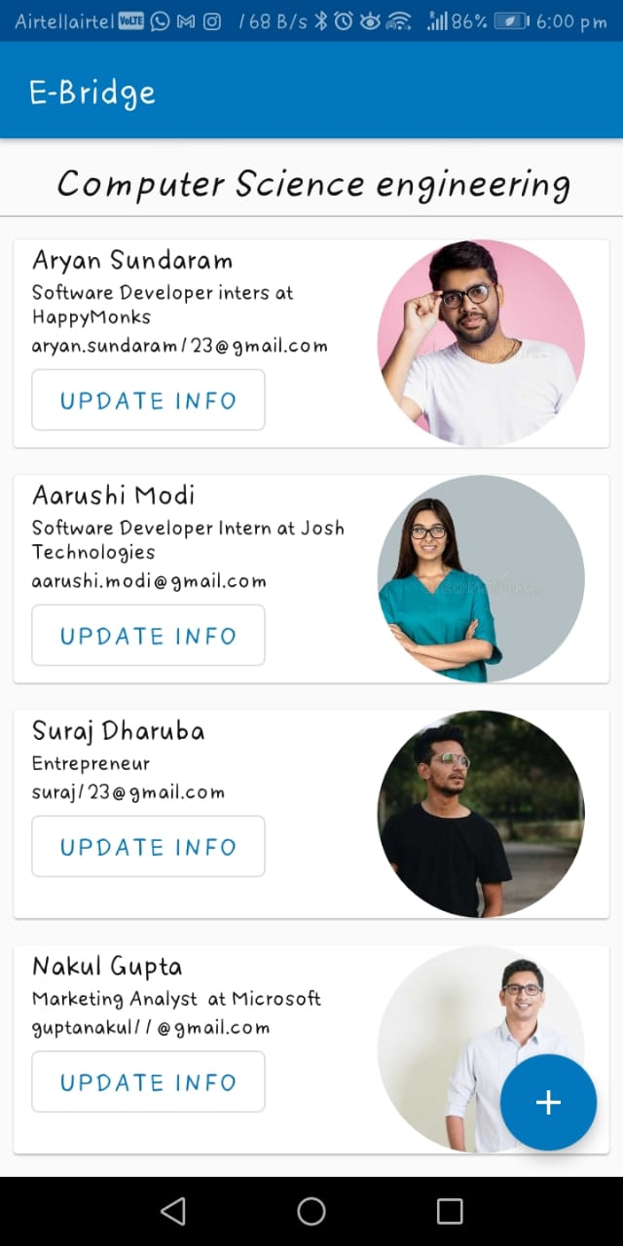

**5.1.6 Add Alumnus**

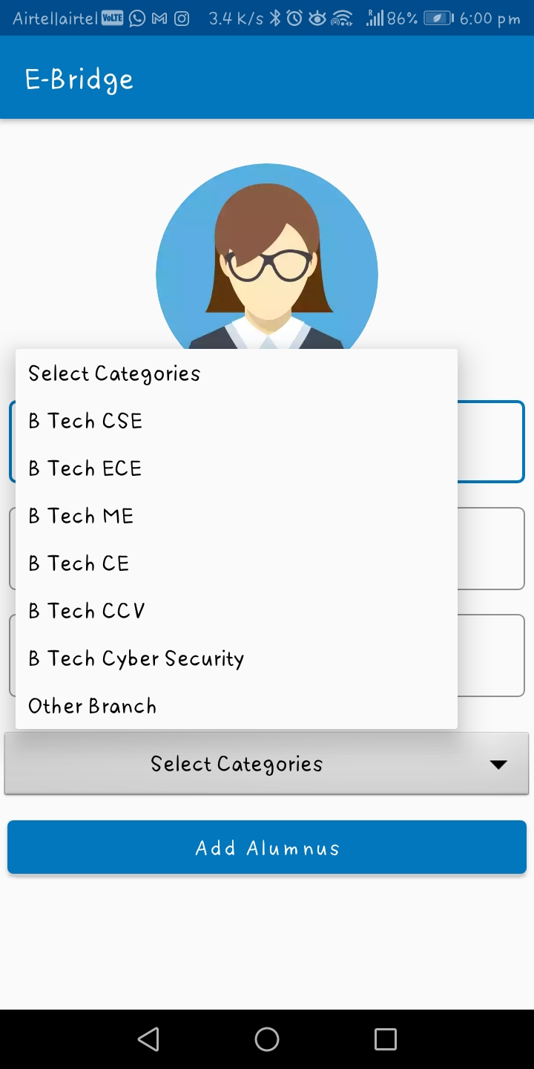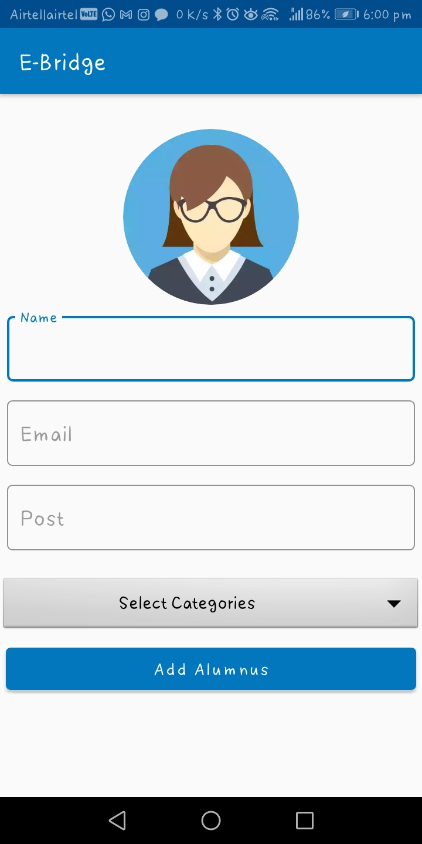

**5.1.7 Update and Delete Alumnus**

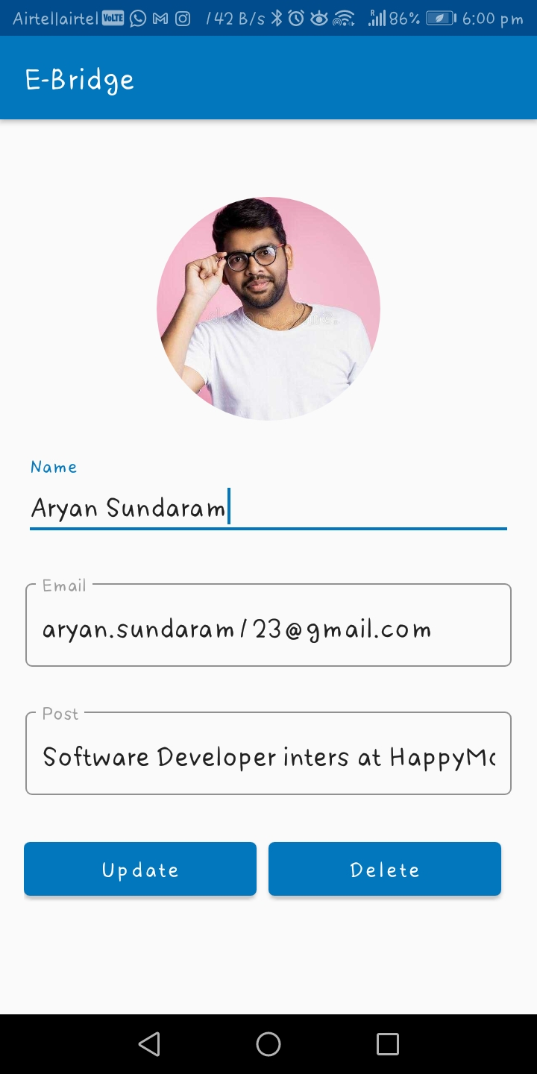

**5.1.7 Delete Notice**

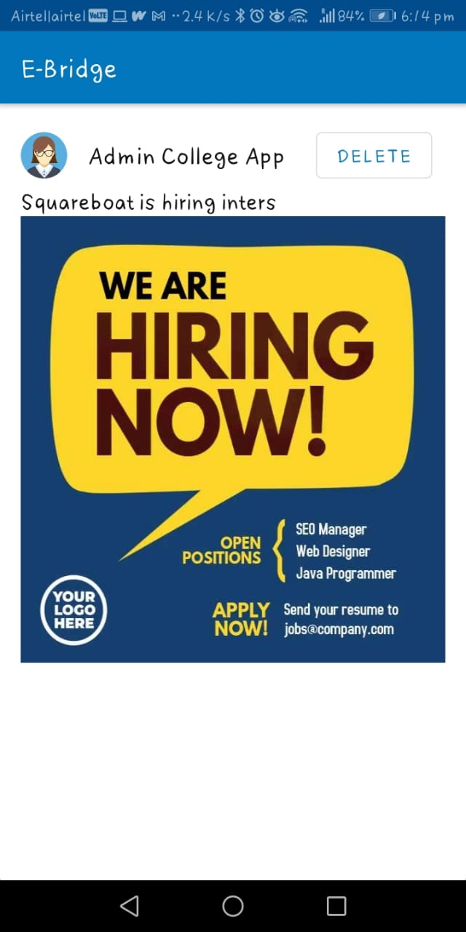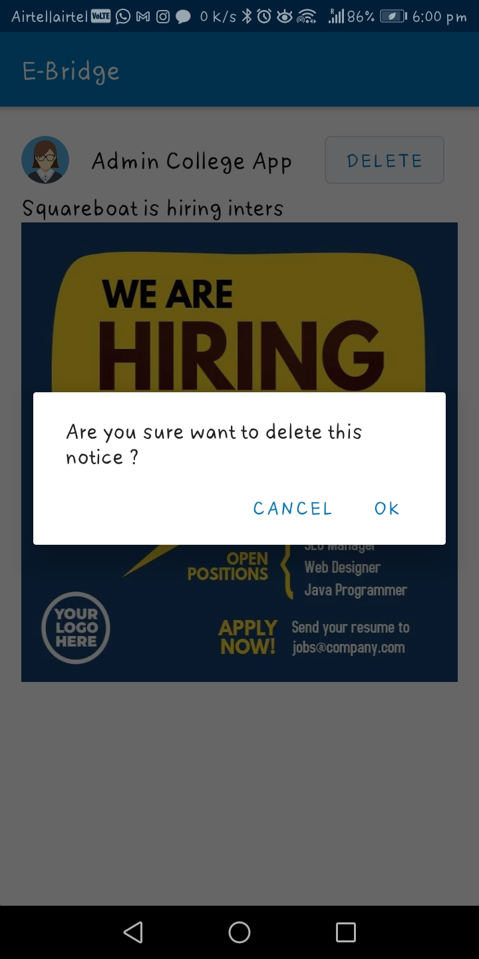

5.2 User Application

5.2.1 Login

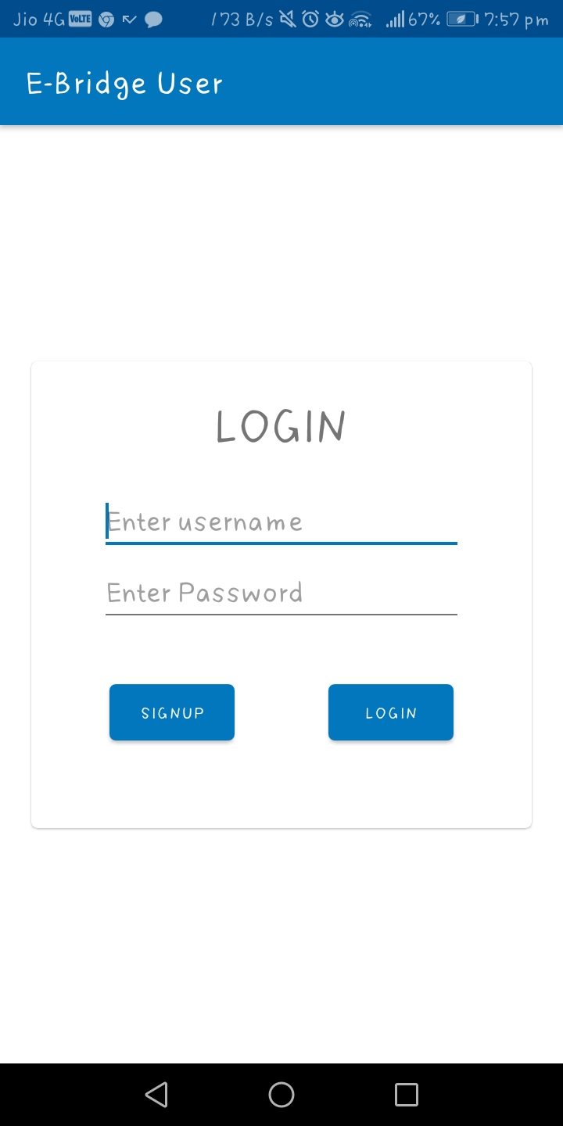

5.2.2 Signup

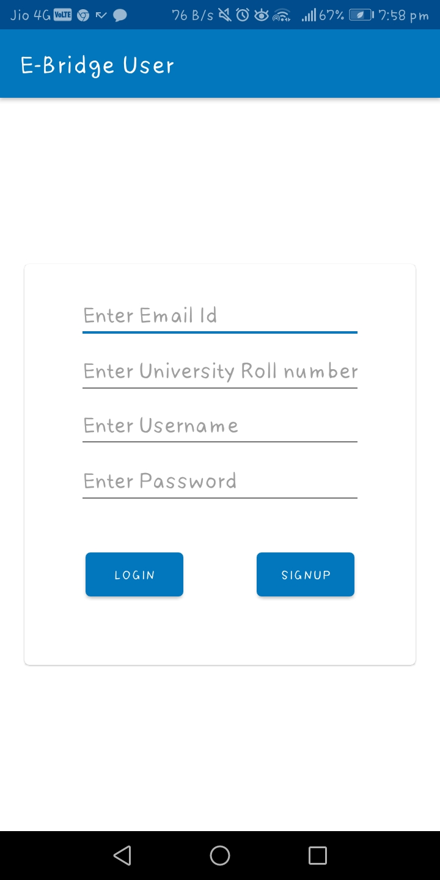

5.2.3 User Dashboard

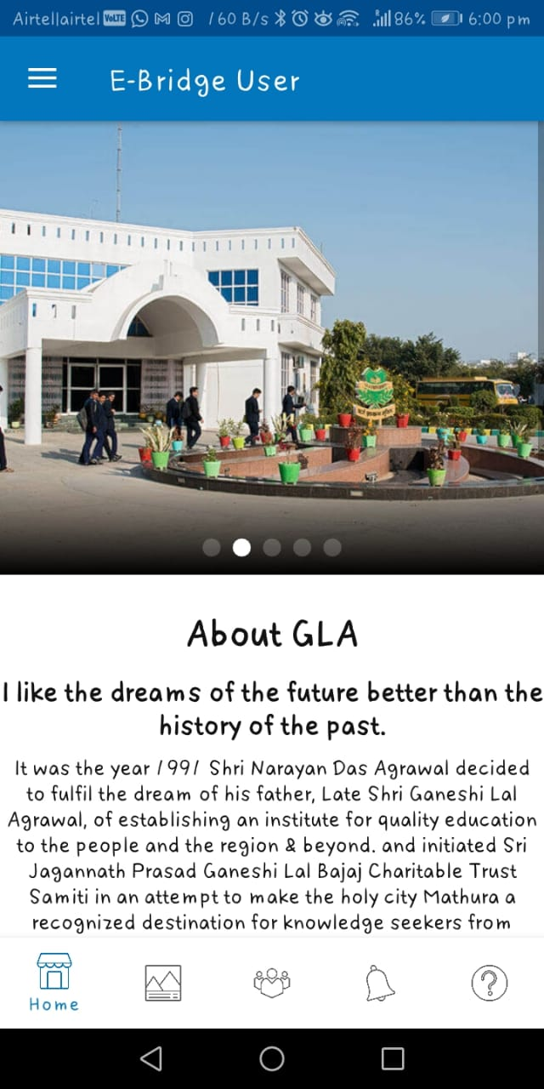

5.2.4 Drawer

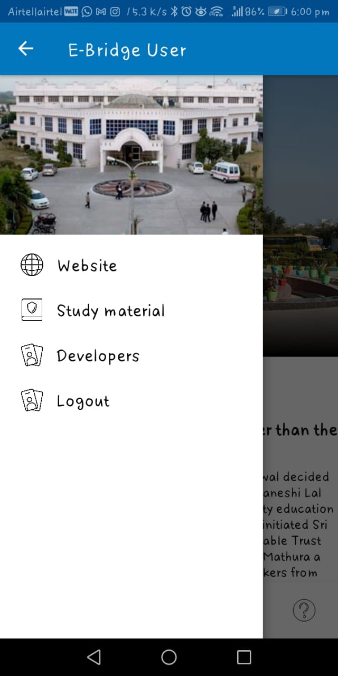

5.2.5 Gallery

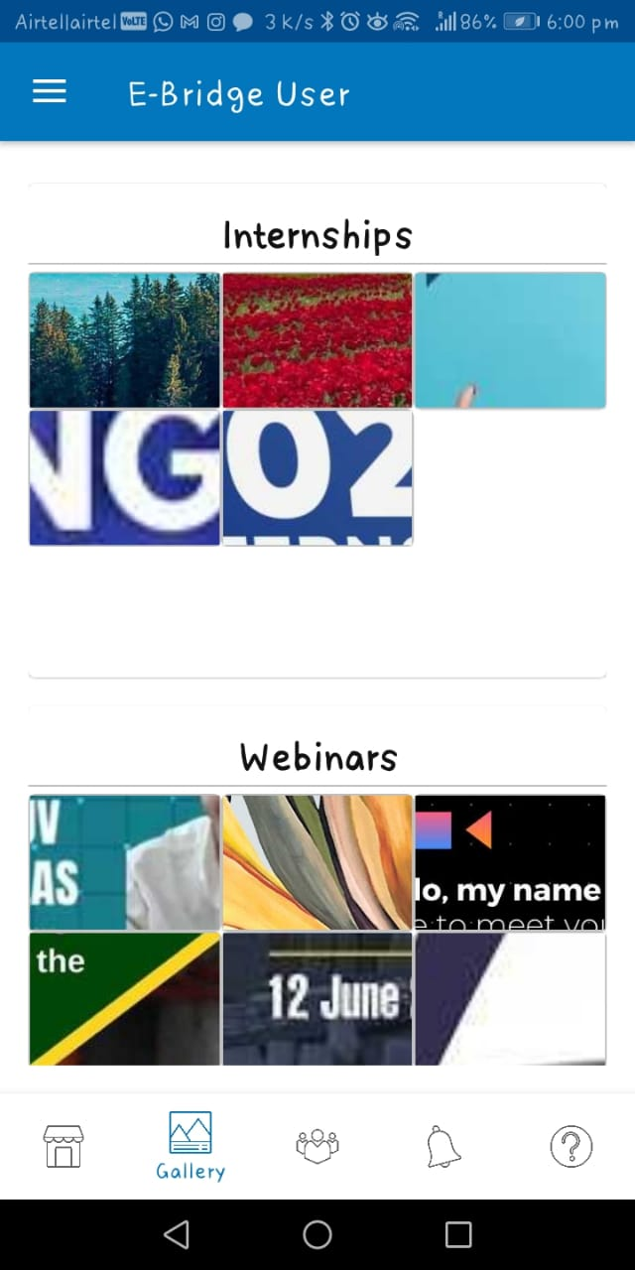

5.2.6 Alumni and Connect

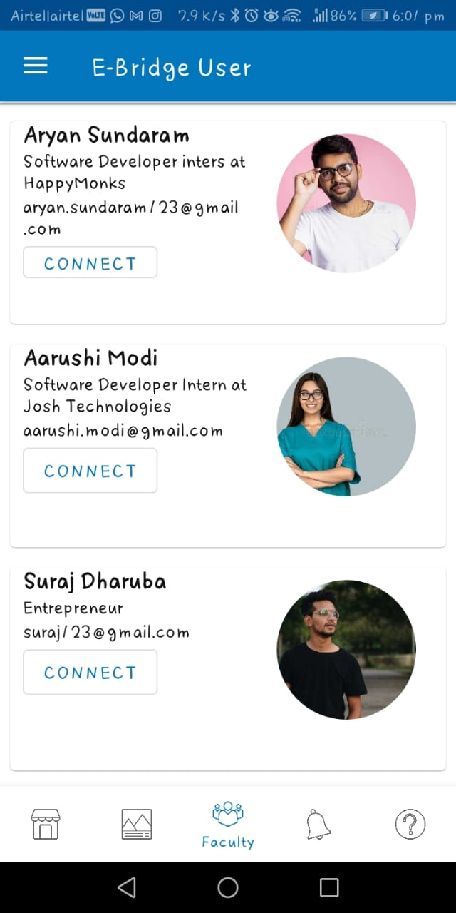

5.2.7 Notices

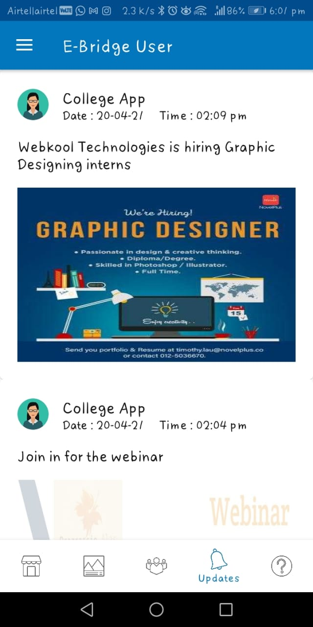

5.2.8 Courses

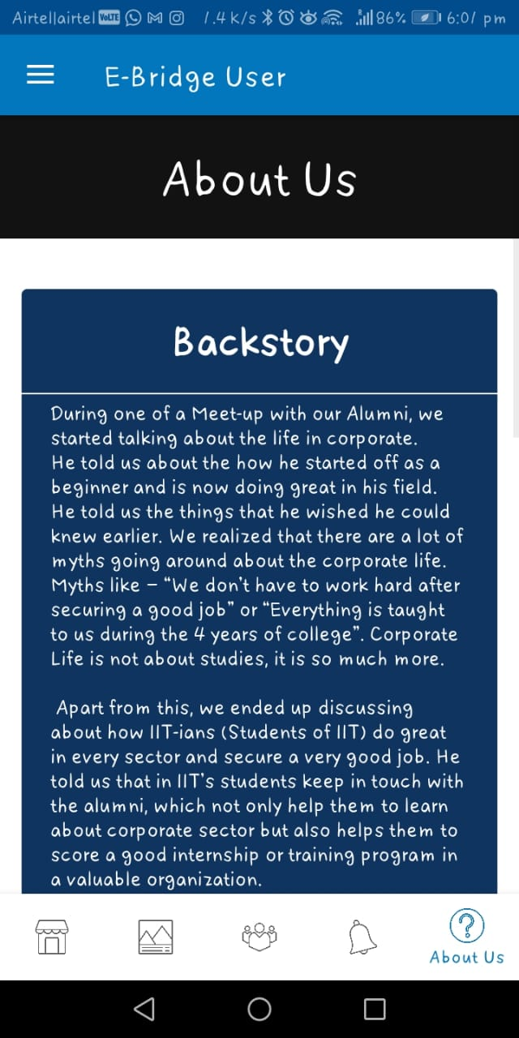

5.2.9 Website

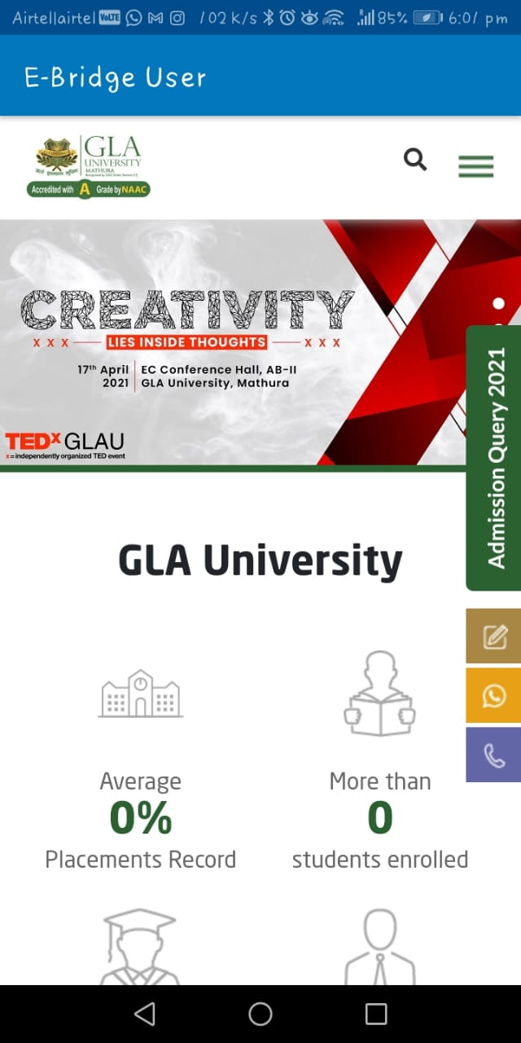

5.2.10 Pdf View and Download

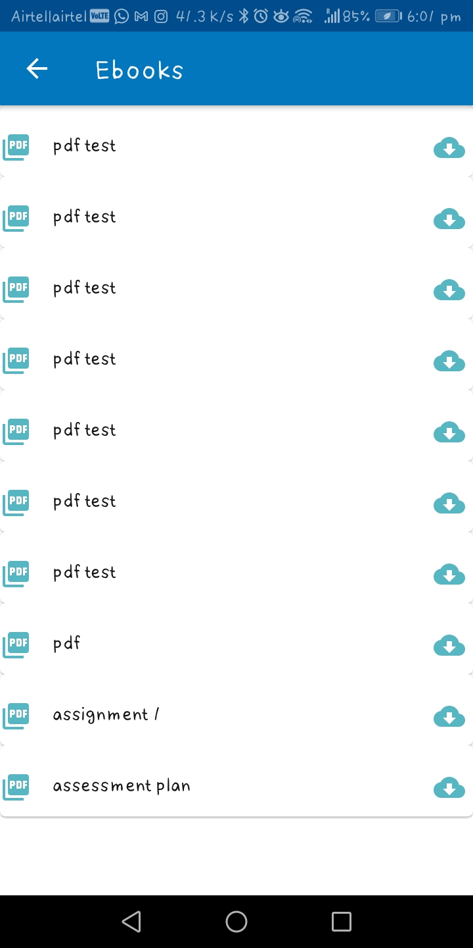

5.2.11 Developers

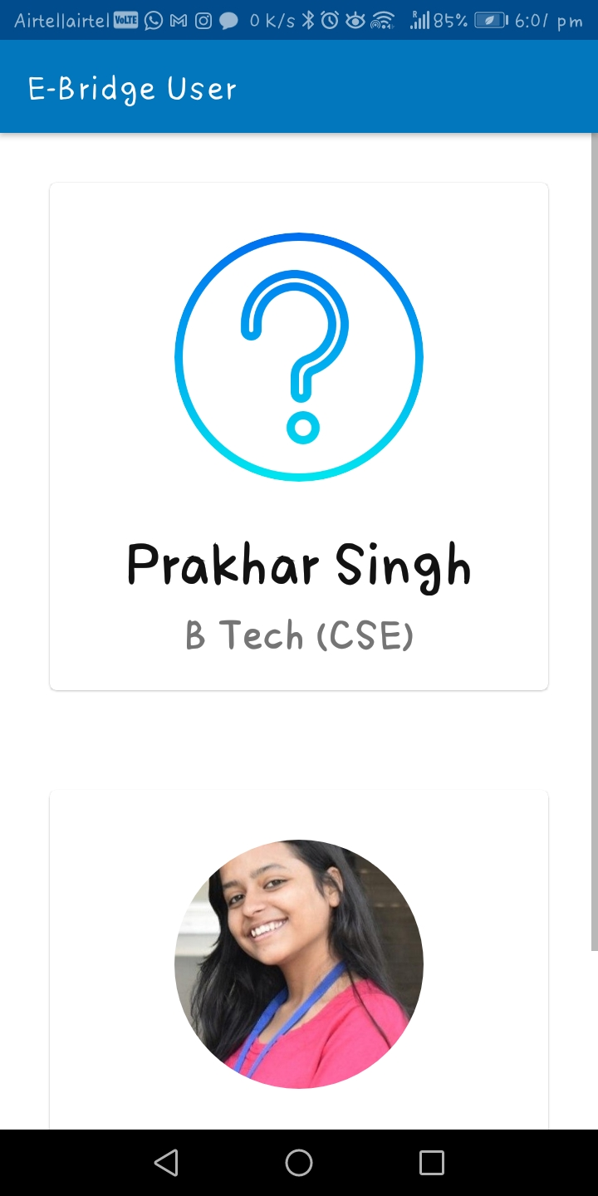

**5.3 Firebase Database**

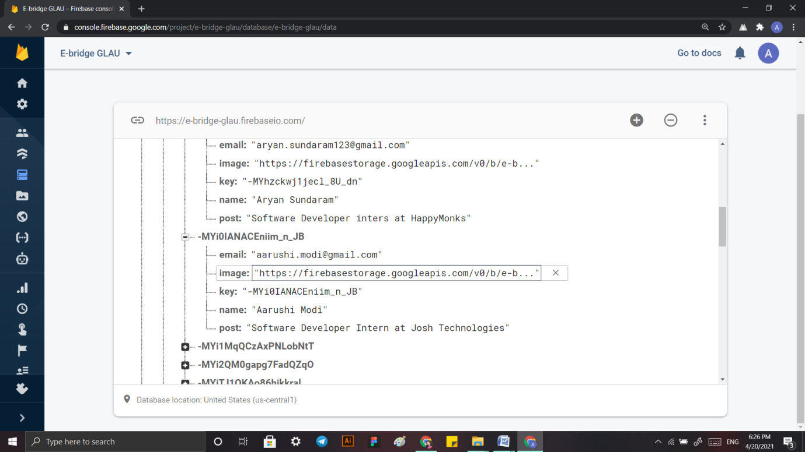

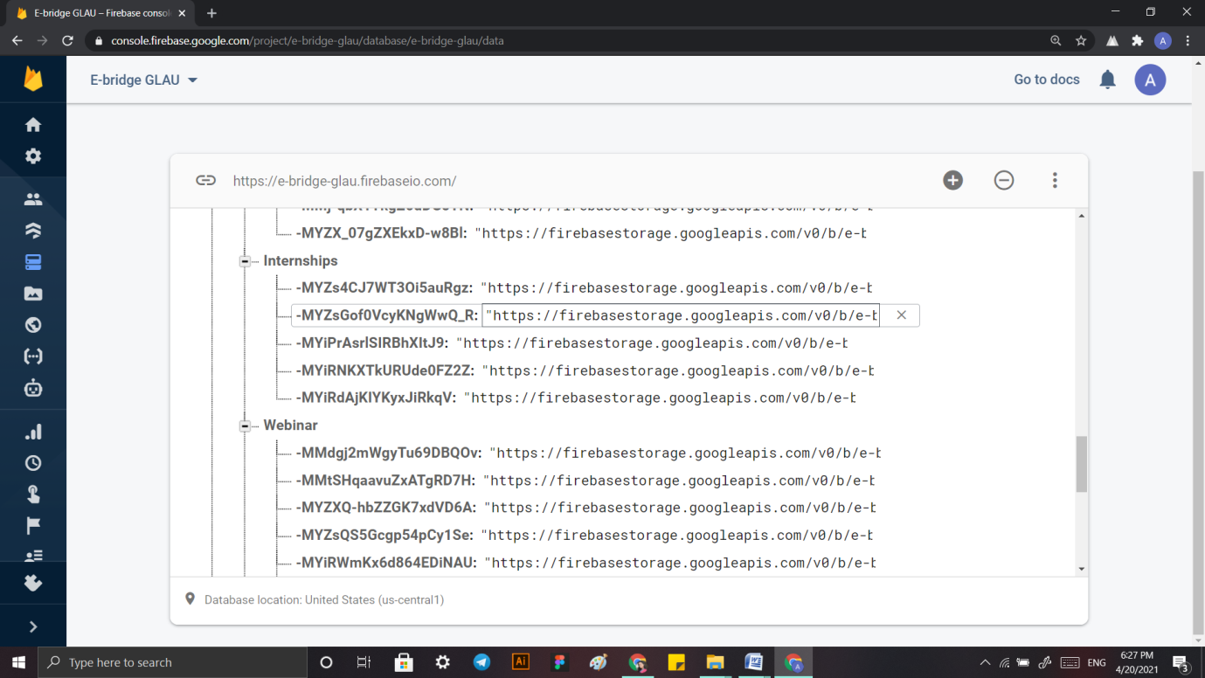

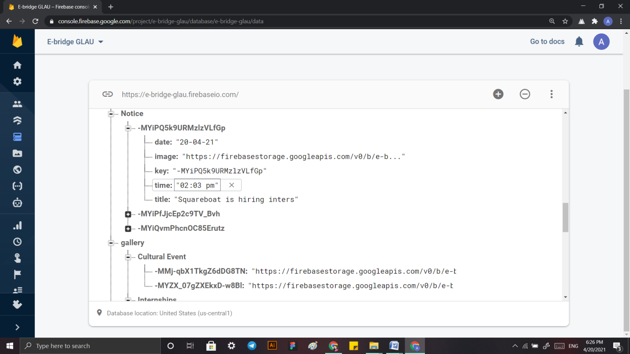

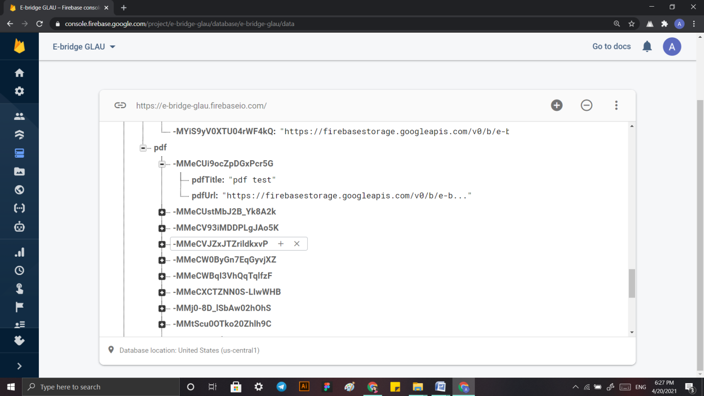

**5.4 Coding**

5.4.1 User Application

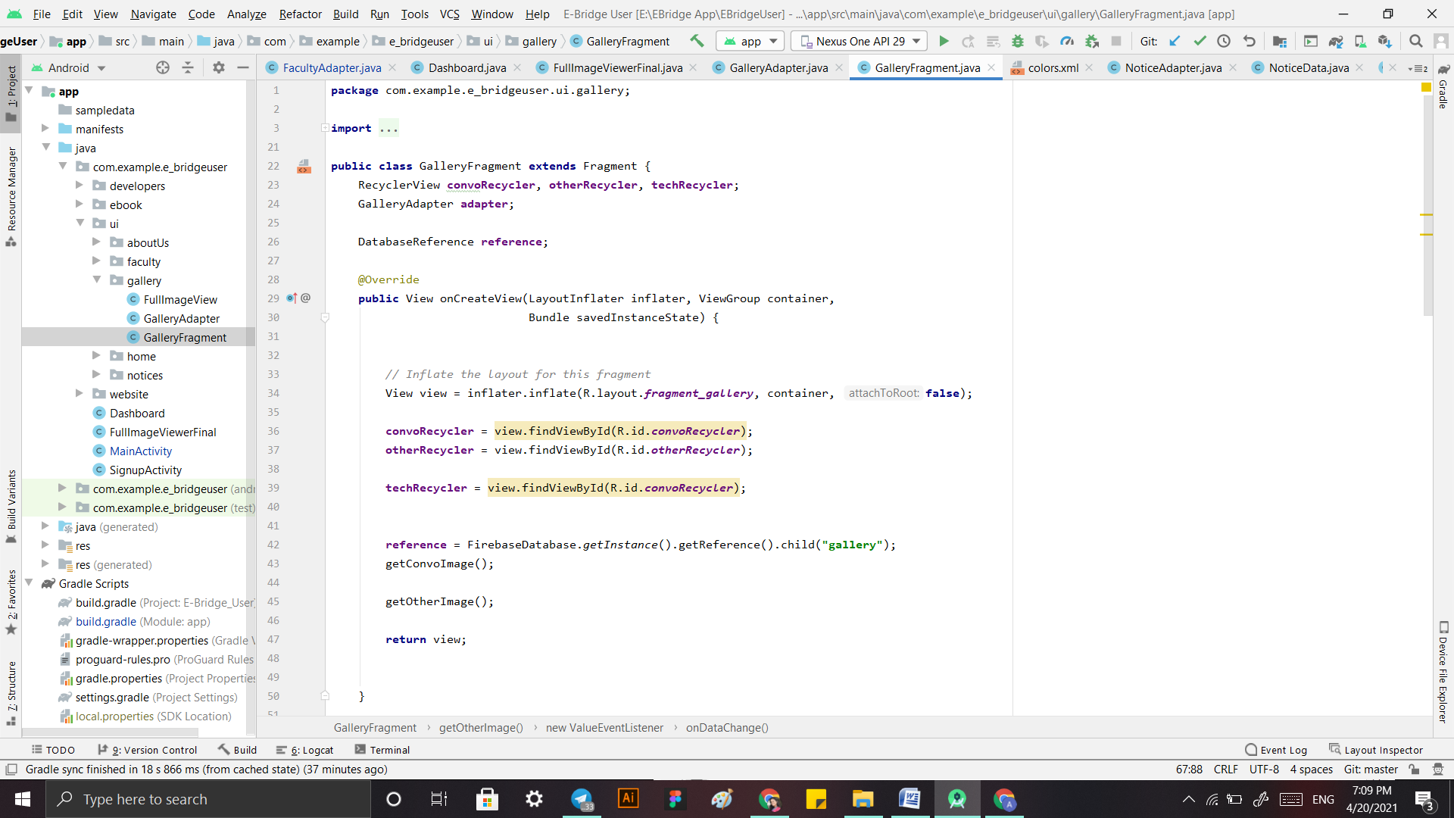

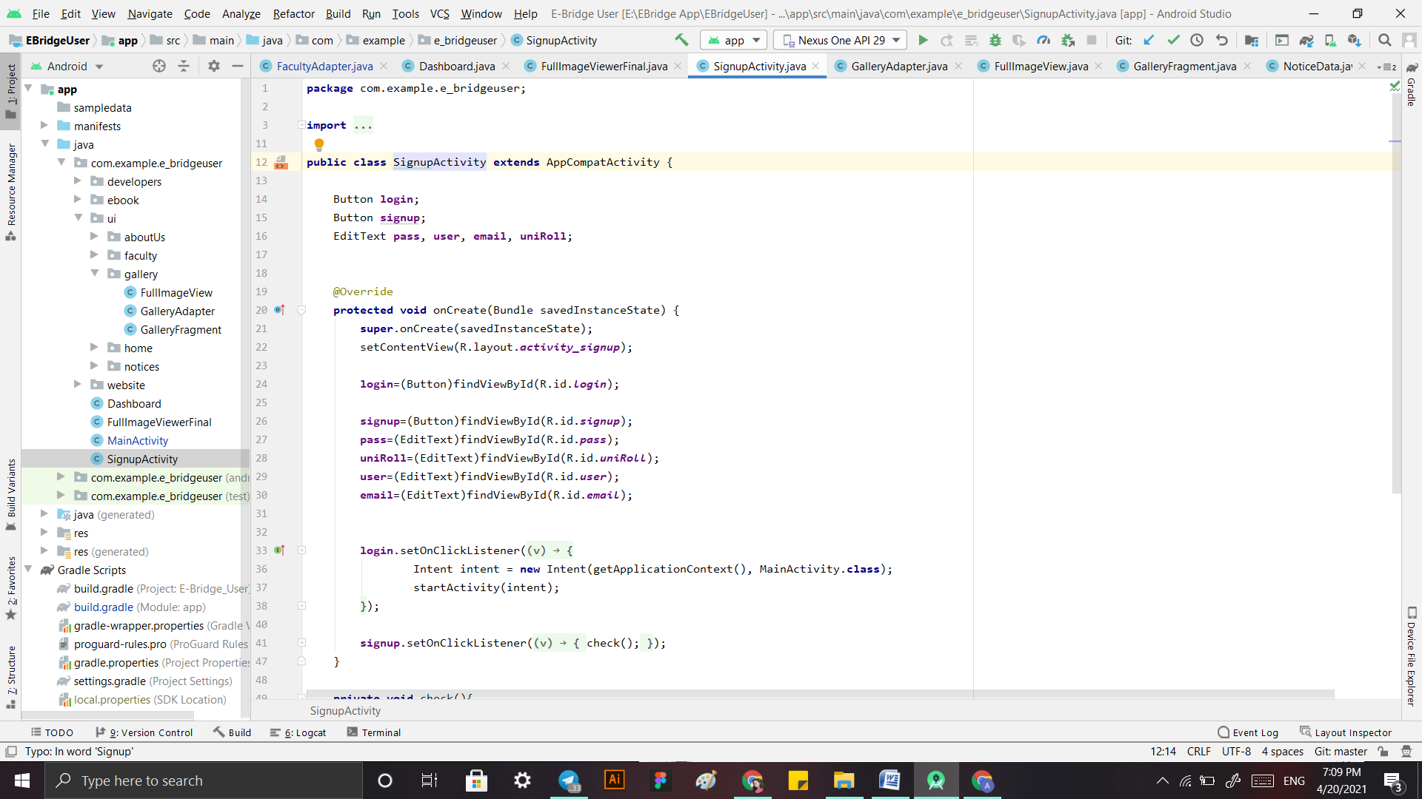

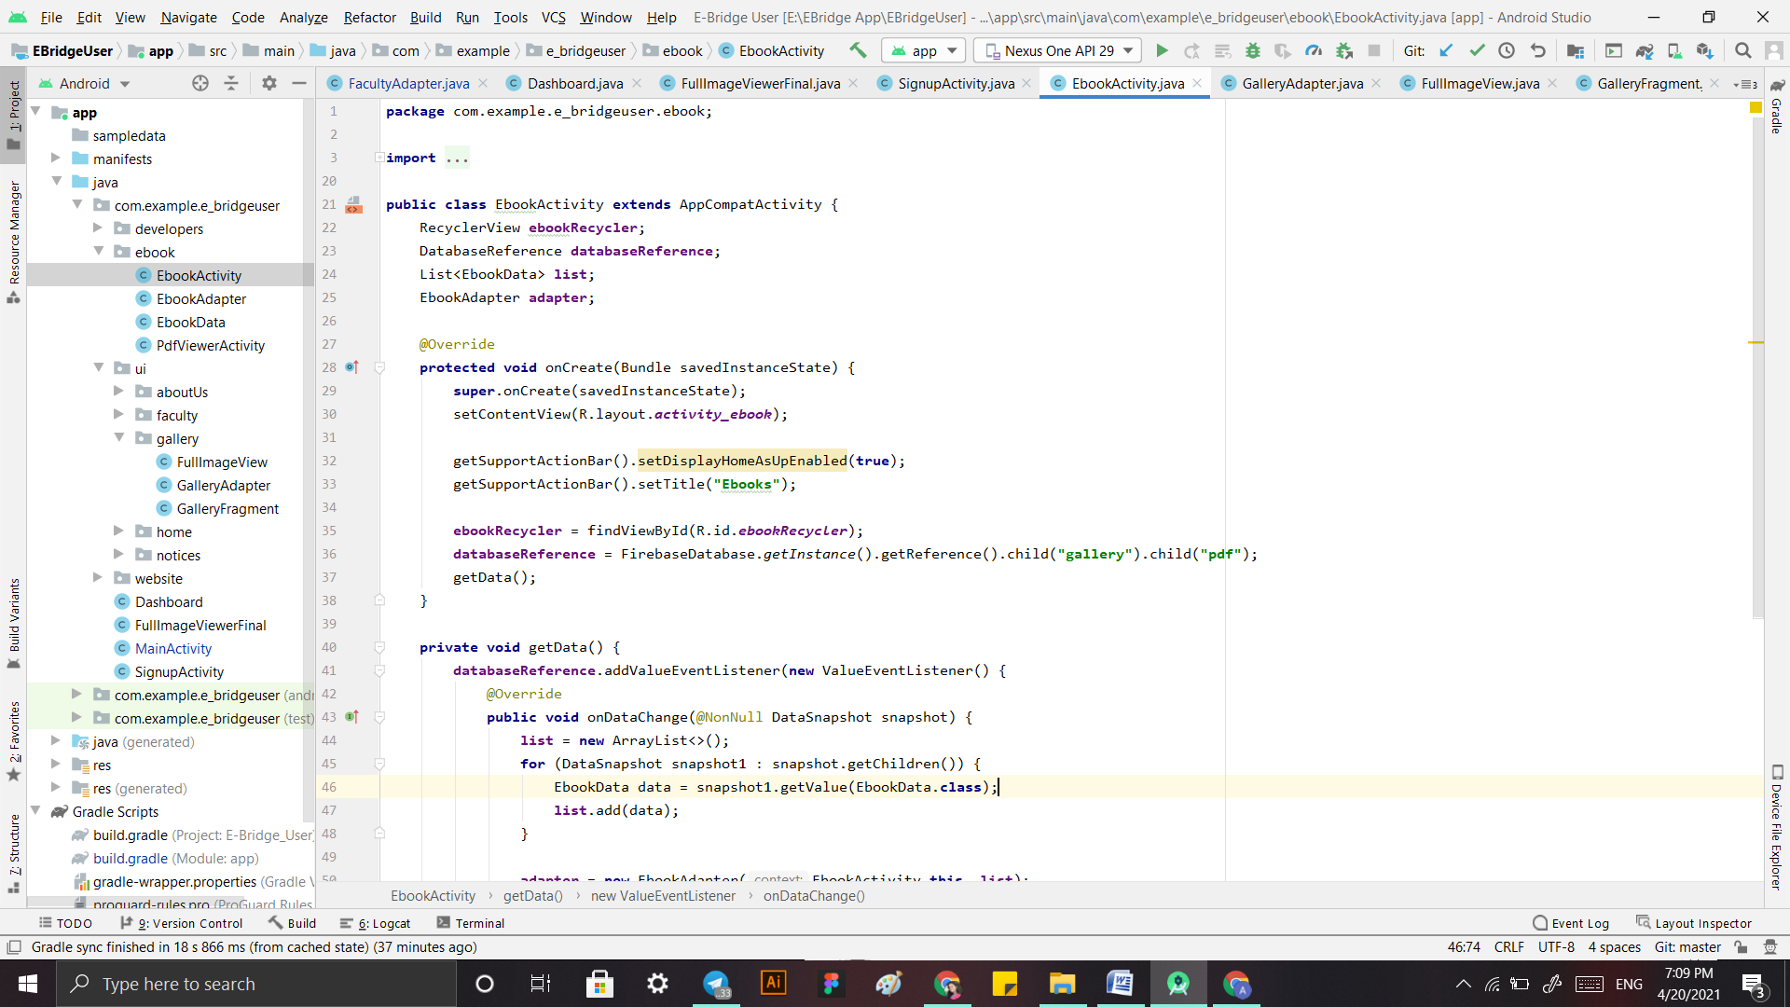

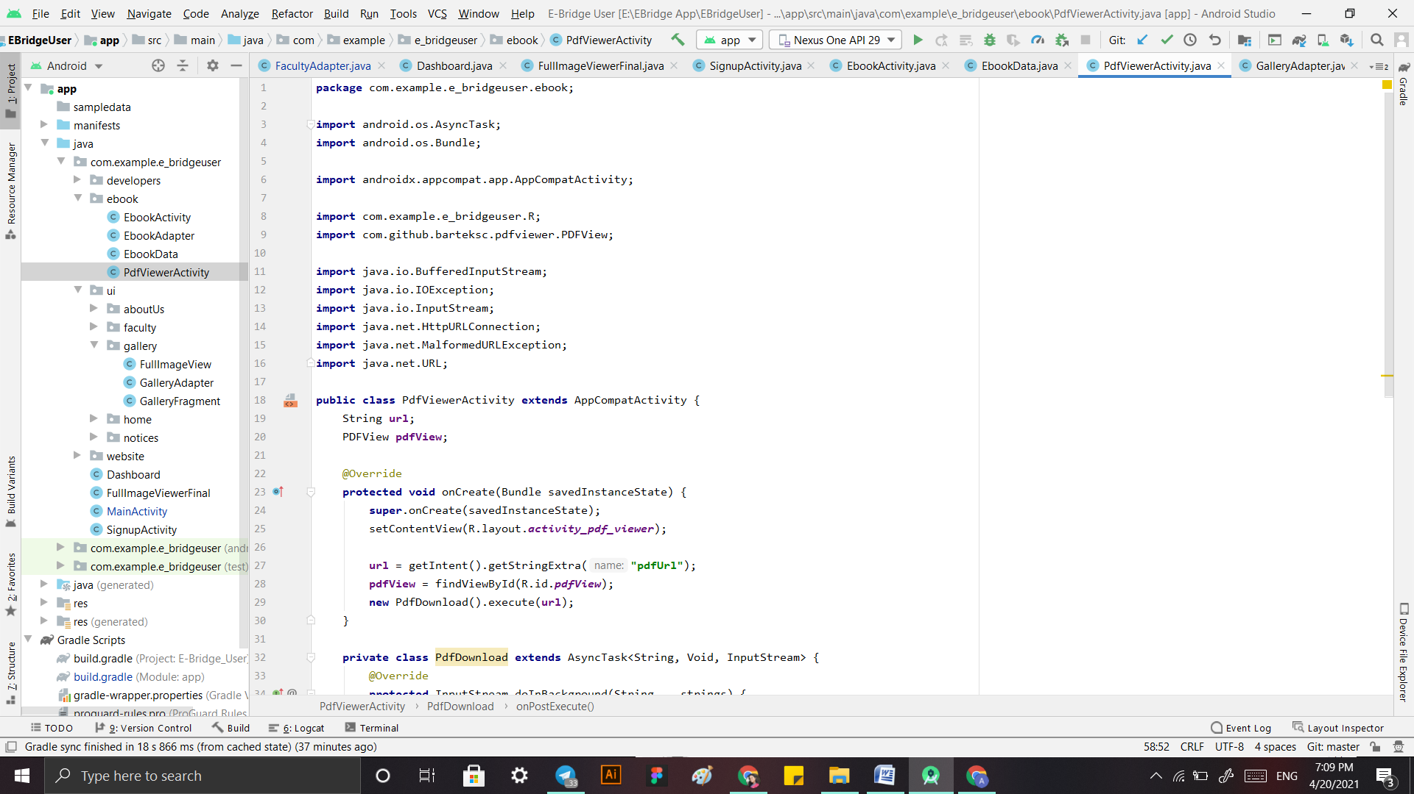

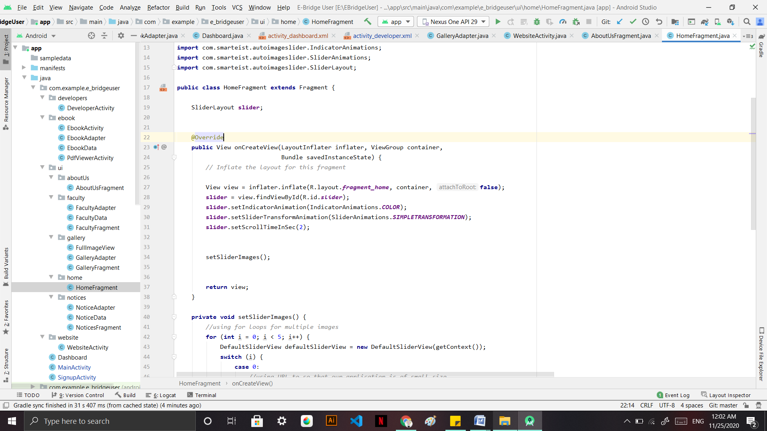

5.4.2 Admin Application

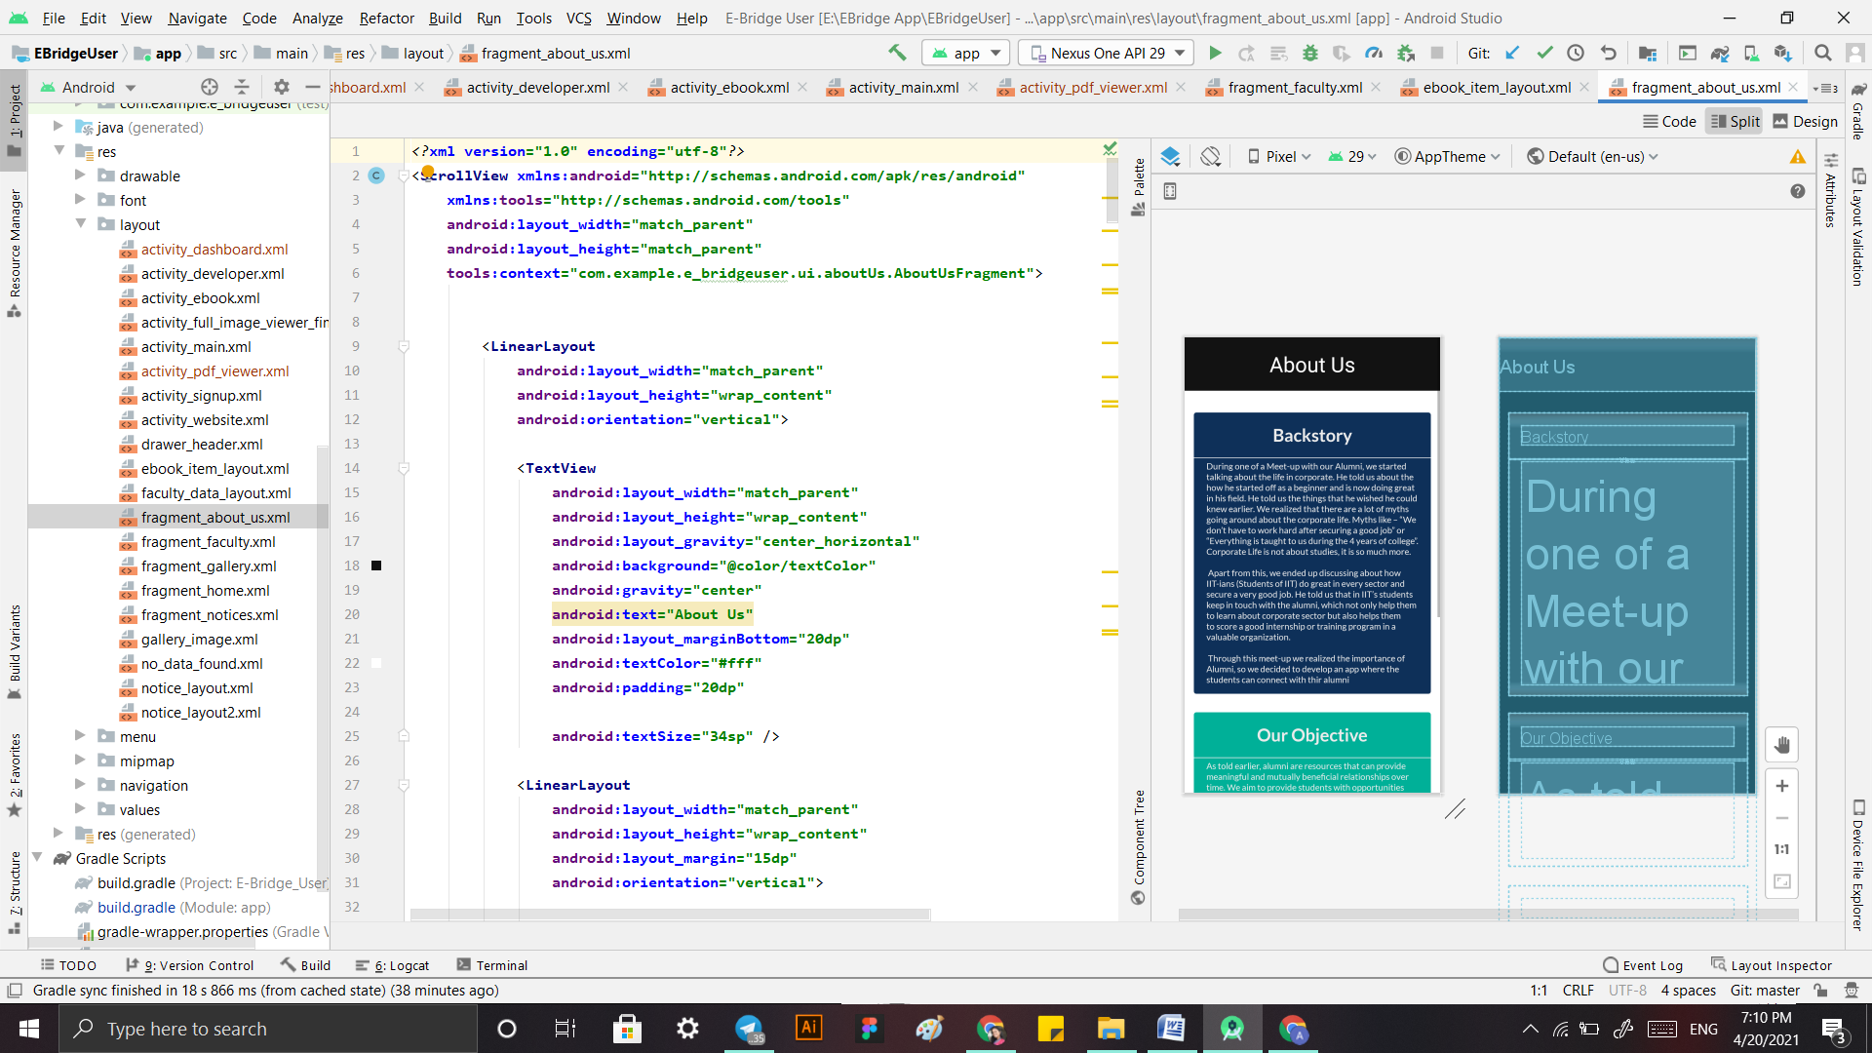

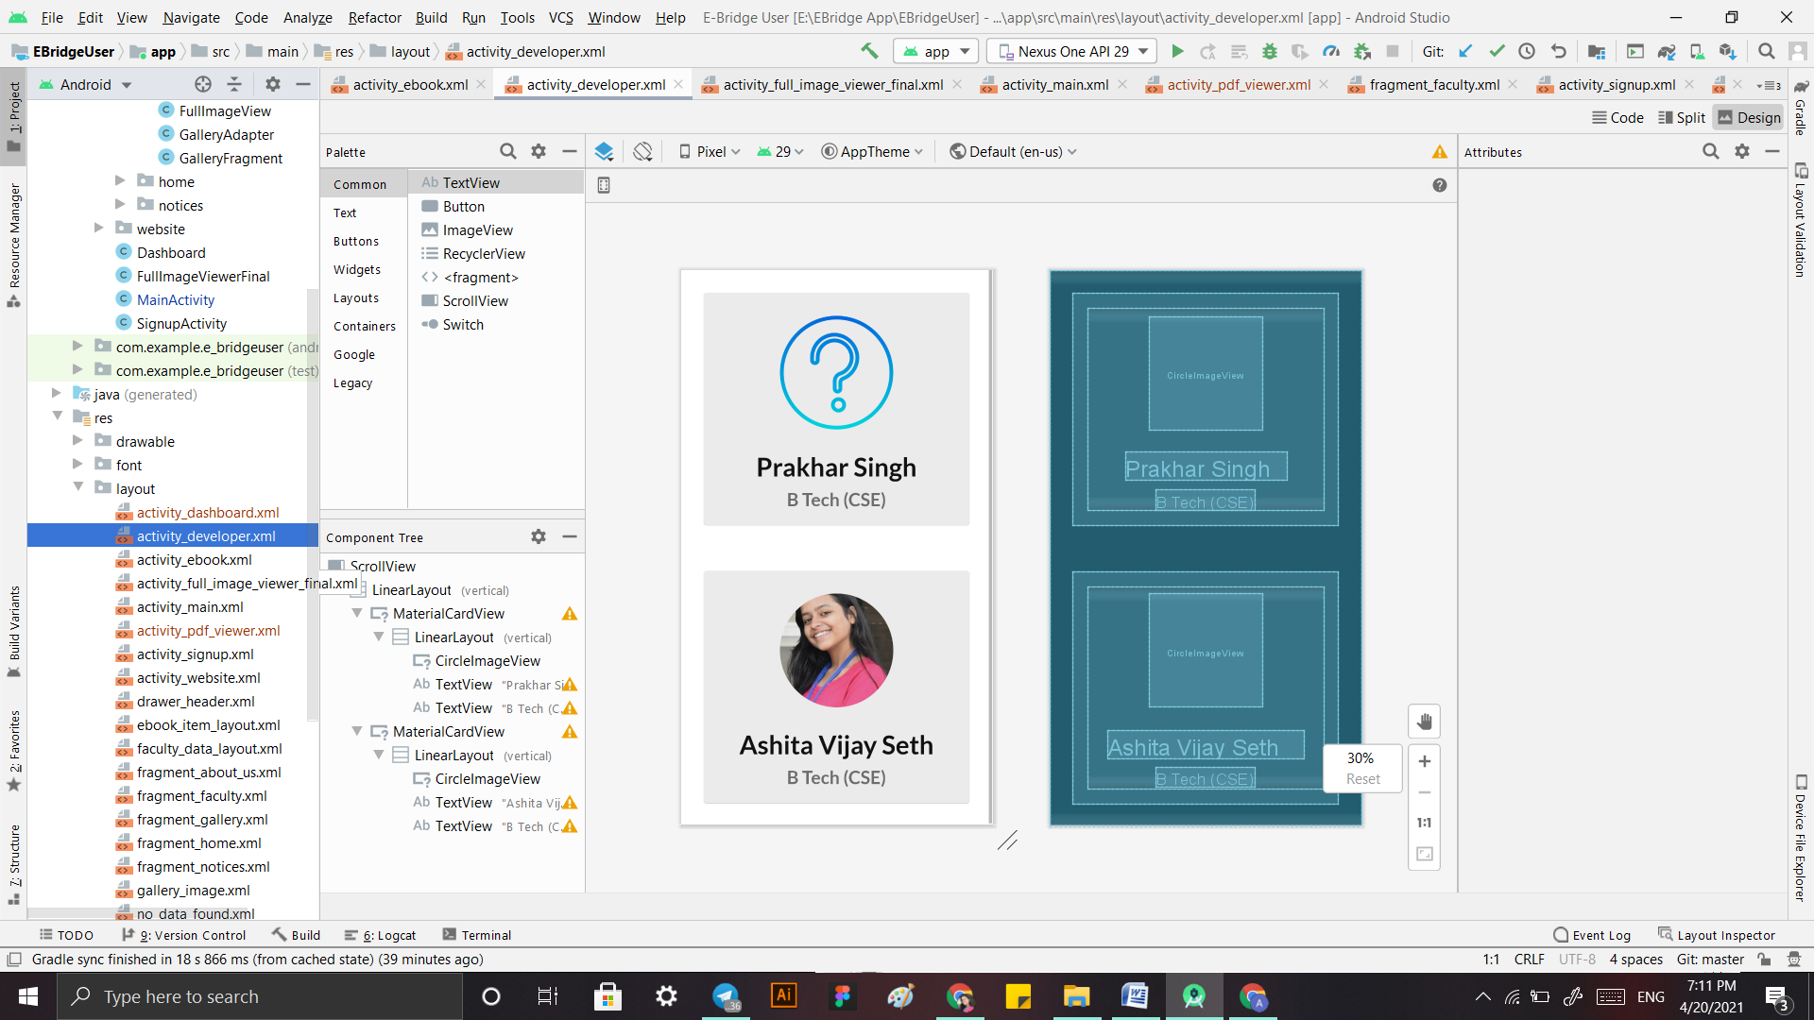

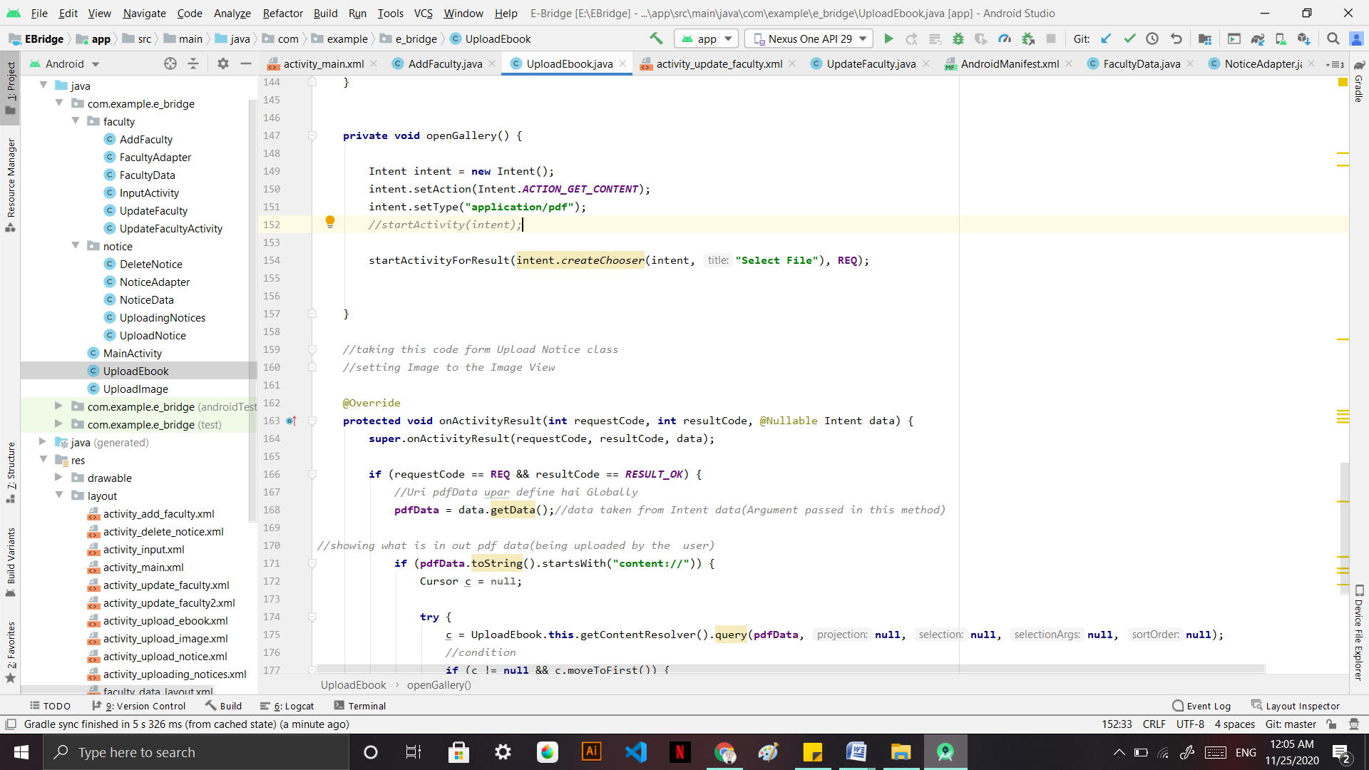

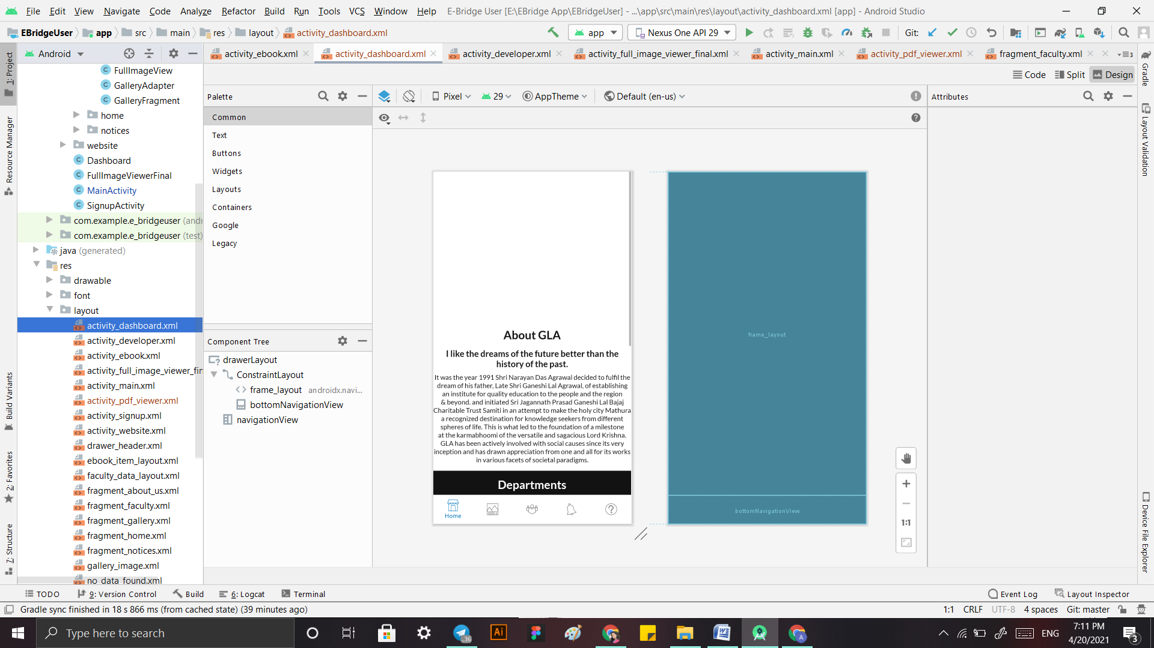

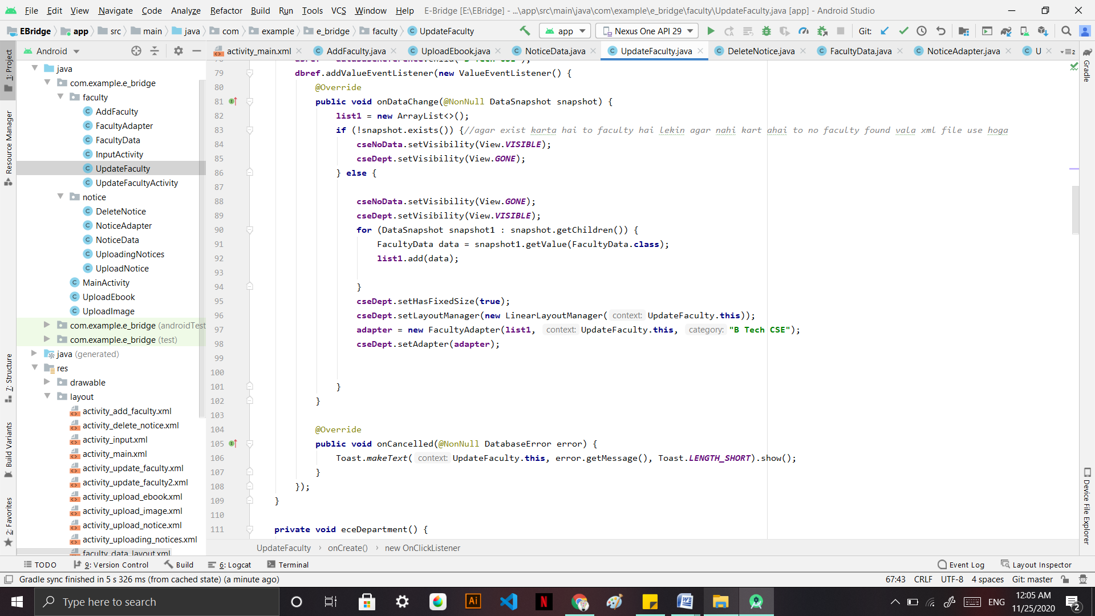

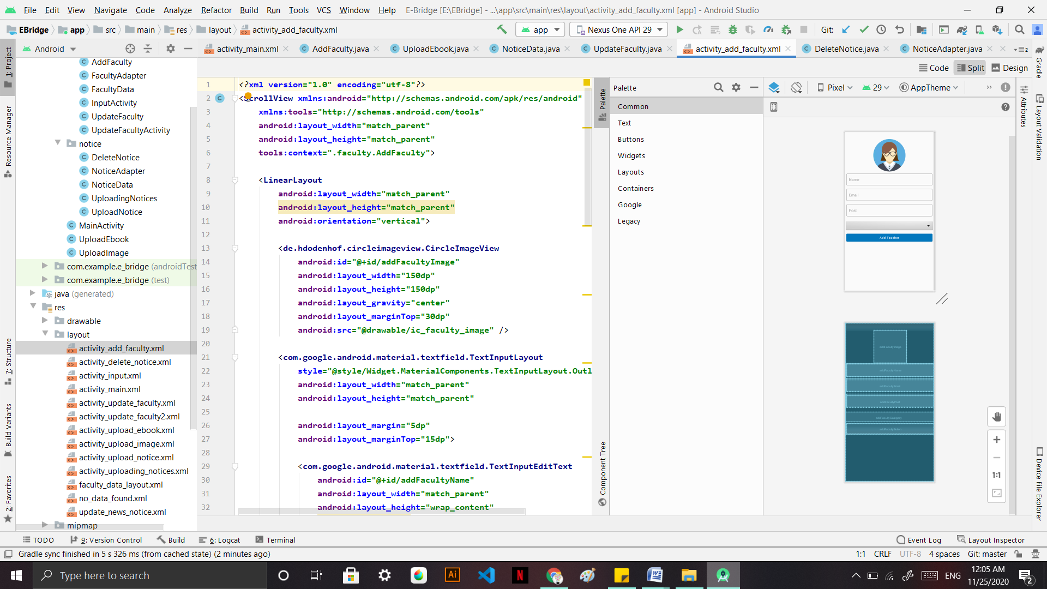

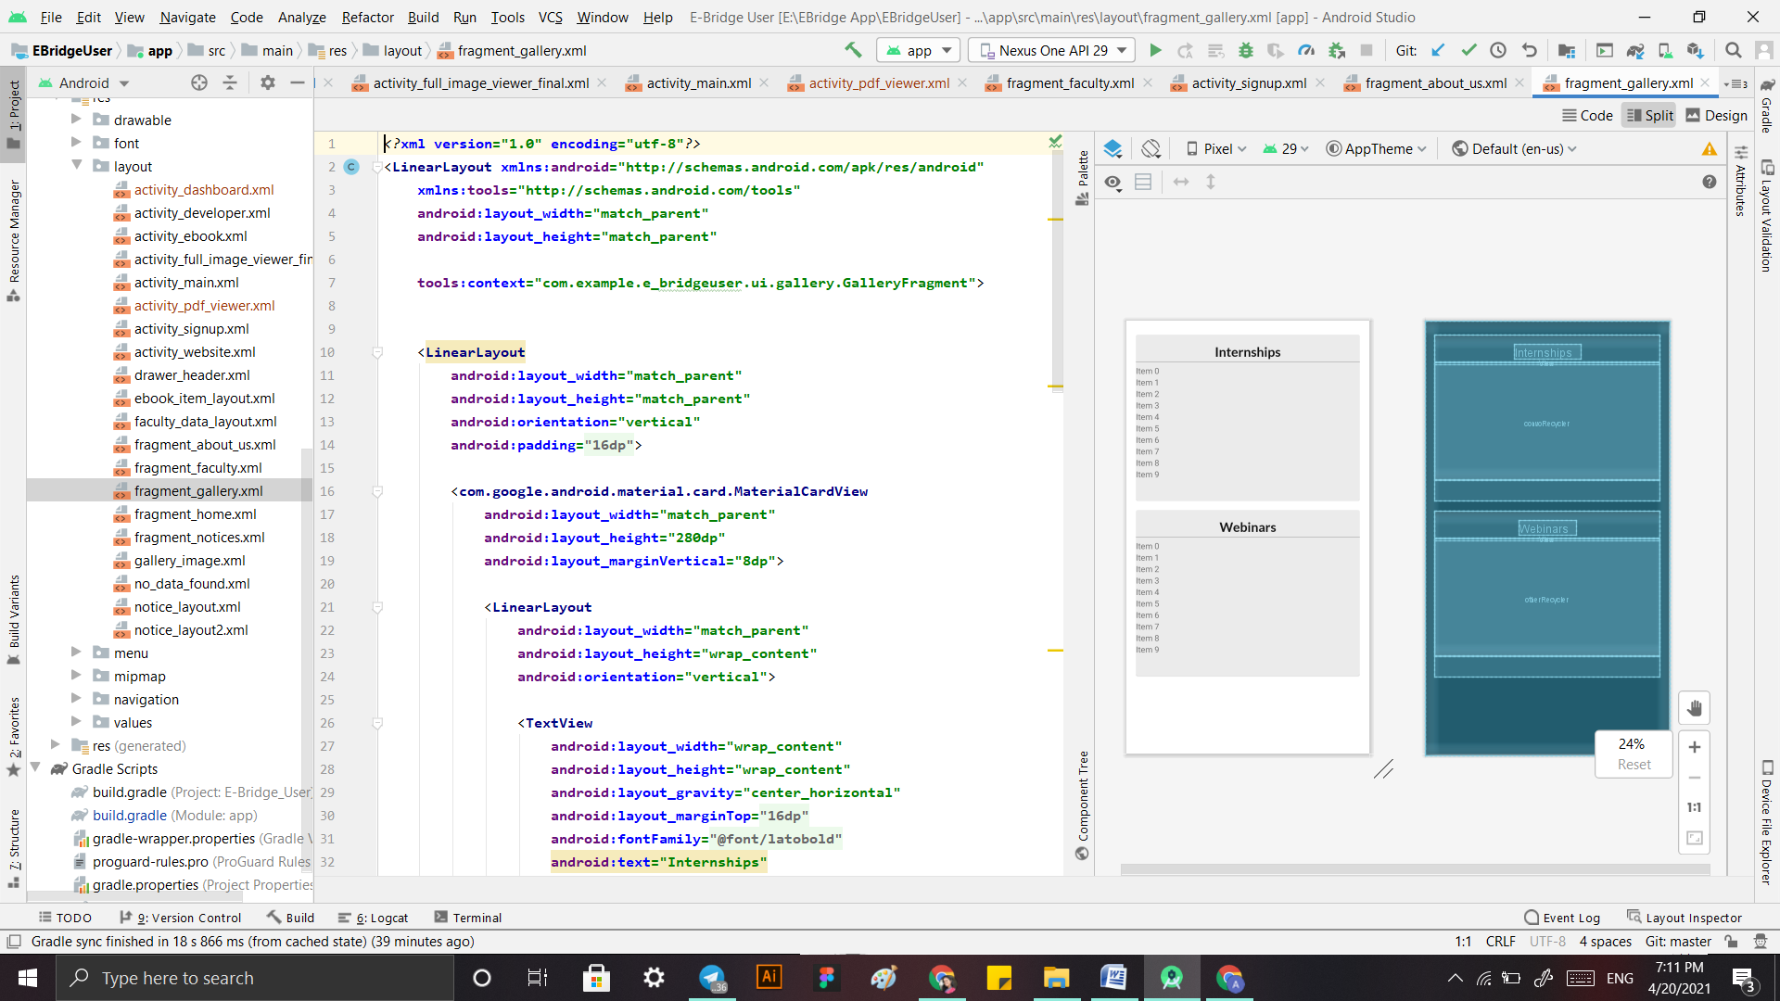

**CHAPTER 6**

**Conclusion**

Alumni Connect will welcome many opportunities which will be beneficial for the students and their career. Regular Updates will make this app more efficient and user friendly. The communication gap between the students and the Alumni will be bridged which will benefit the students by providing them with real life experiences and guidance which will help them in long run

**References**

* <https://www.signalvine.com/alumni/why-alumni-are-important-for-higher-ed-institutions#:~:text=Alumni%20serve%20many%20valuable%20roles,and%20career%20opportunities%20to%20students>.
* <https://www.themuse.com/advice/7-alumni-benefits-you-should-be-taking-advantage-of>
* <https://www.youtube.com/>

## Signature of Project Guide: ________________________